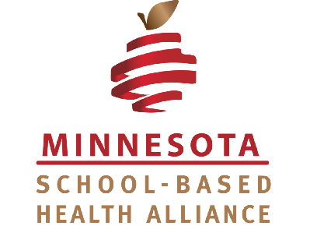
March 20, 2023

Dear Chair Liebling and Health Finance and Policy Committee,

As the MN School-Based Health Alliance, we are writing to offer education and support on the impact of school- based health centers on the health and education equity of Minnesota students. Thank you for thoughtfully uplifting this safety net for children and teens. We support the language in HF 2930 that extends support to emerging and existing School-Based Health Centers in Minnesota as well as MN Department of Health’s work in this area, and our role as a capacity-building organization in community.

School-based health centers (SBHCs) have been strongholds of accessible, equitable and comprehensive preventive care for students in Minnesota for 50 years. If passed, this legislation would be the first state policy and dedicated funding to support school-based health centers in that time. An investment in SBHCs at this pivotal time for the health of children and communities would be historic.

The gold-standard model for school-based clinics had its genesis here in St Paul, Minnesota, and is now codified in federal statute. Today, over 2,200 school-based health centers operate across the U.S. Until 2022, our local School Based Health Alliance was a voluntarily coalition of the leaders who operate school-based clinics. In MN, there are now 29 providing care to nearly 15,000 students, and at least 11 in development. The Alliance represents and supports each of the health care providers and districts.

The Alliance is a long-term community partner of the Minnesota Department of Health (MDH). MDH has provided a convener to support this work since 2015 when the Alliance became an official affiliate of the national School- Based Health Alliance. In January, MDH extended a CDC COVID Workforce grant to the Alliance, now a nonprofit, to assist schools with pandemic recovery. During distance learning, the mental health therapy, medical care, nutrition services, health education, and parent support delivered in Minnesota’s school-based clinics proved SBHCs are a durable part of the health care safety net. As pediatric clinics, family physicians, dental clinics, mental health care centers and more providers struggle to meet the needs among kids, school-based access to care creates ease for families, supports a fractured health care system, and strengthens school-health initiatives.

We welcome the opportunity to provide expertise and advocacy toward the continued growth of this critical part of Minnesota’s safety net and pivotal partnership with MDH.

Evidence shows partnership between a local Alliance and a state program office like MDH, and dedicated state funding for new and existing school-based health initiatives, correlates with expansion of care for kids, decreases Medicaid costs and increases school success. Growth has been slow in Minnesota compared to most other states. This is a critical time to change that, particularly in rural areas where one school-based health center can offset care shortages for an entire community. This bill allows school-based health providers to be here for kids as they recover from the pandemic, a time when their needs are critically underserved and increasingly acute.

Care within SBHCs is not a replacement for the allied health professionals in schools such as Licensed School Nurses, School Counselors, and Social Workers. Simply said, their co-existence creates ease for families and optimizes learning. Expanding this to more children is a key lever for reducing disparities in education and health outcomes for children in Minnesota.

In health,
Shawna Hedlund
MN School-Based Health Alliance

The school-based health alliance supports the expansion of school-based clinics in school districts across Minnesota to address health and education disparities and ensure that every child has an equitable opportunity to meet their full potential.

WHAT ARE SCHOOL-BASED CLINICS or HEALTH CENTERS?

School-Based Clinics or SBHCs are a transformational and time-tested healthcare model that delivers care to children and adolescents where they spend most of their time – in school. They efficiently and cost effectively address health inequities like access to medical care, mental health support, dental and eye care. School-based healthcare means that students K-12 can get a flu shot, have an annual physical, have their teeth examined and their eyes checked, or speak to a mental health counselor in a safe, nurturing place without the barriers that families too often face - barriers like cost, transportation, lost work time, lost class time. SBHCs represent one of the best models for assuring ALL children and adolescents can enjoy school and learn.

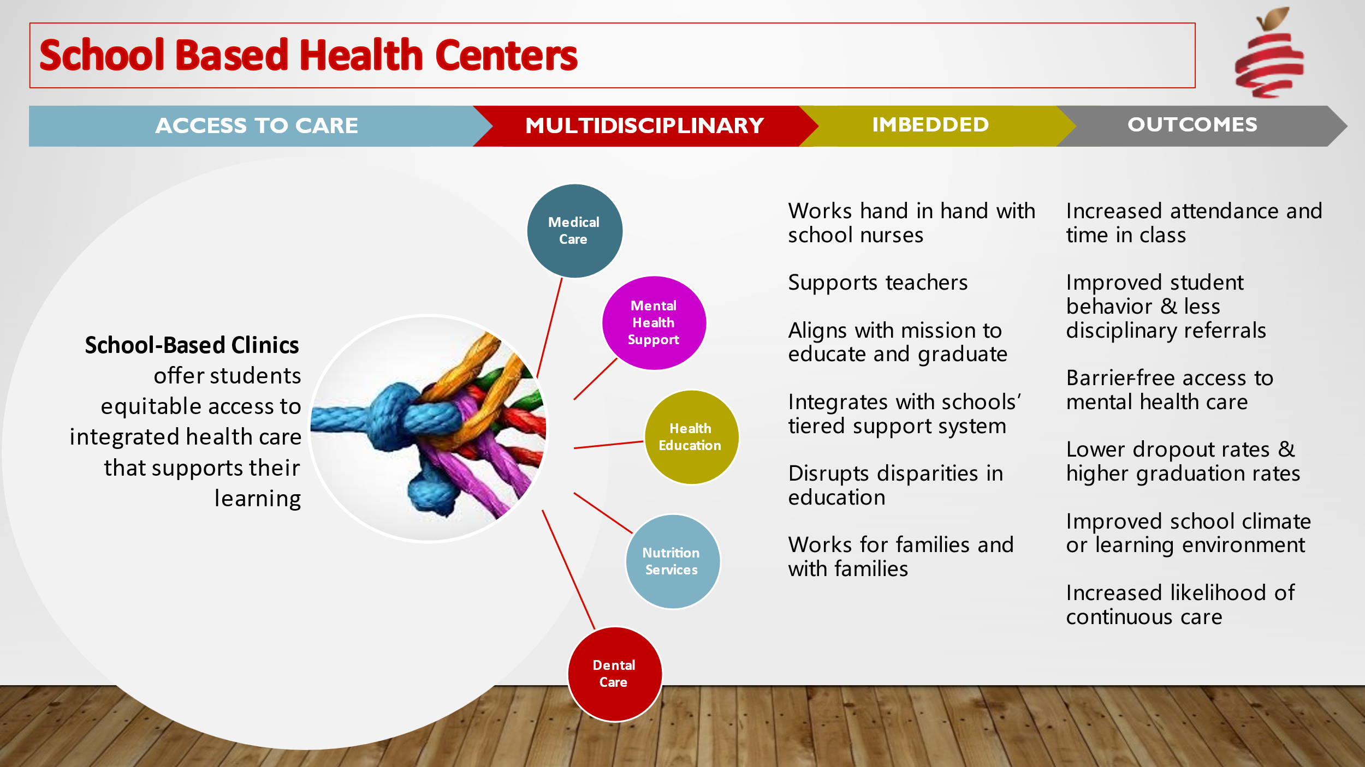

MINNESOTA SCHOOL-BASED HEALTH ALLIANCE

The Alliance is the capacity-building and technical assistance alliance for school-based health centers in Minnesota. We support school districts and health care organizations operating and initiating school-based health centers by providing community advocacy, science-based expertise, shared resources, and a Community of Practice.

CLINIC LOCATIONS Map: 29 established sites under 9 operators and 11 emerging initiatives

Twenty-nine school-based health centers exist in Minnesota today and more are emerging. Over 30% of SBHCs in MN are operated by federally-qualified Community Health Centers. The CDC Social Vulnerability Index uses 16 variables to identify communities that need support. All SBHCs in Minnesota are located within the highest quartile of the social vulnerability index across our communities.

Minnesota Community Care
10 “Health Start Clinics” in St. Paul Schools

NorthPoint Health and Wellness
2 clinics in Minneapolis Public Schools

Minneapolis Health Department
8 clinics in Minneapolis Public Schools

Park Nicollet Foundation
4 clinics in Richfield, Burnsville, Brooklyn Center, and St. Louis Park Schools

Ortonville Area Health Services
1 clinic in Ortonville K-12 School

Mayo Clinics
1 clinic in Rochester ALC

MyHealth
1 clinic in Hopkins School District

Minnesota State University, Mankato
1 clinic in Bloomington Schools

Rise Up Health Clinics
1 “Bear Care Clinic” in White Bear Lake

Most SBHCs in Minnesota are in Metro locations, leaving a gap for rural students. The Alliance is working hard to support communities invested in health care access for their families and students. This model of care has a profound impact on individual students, families, school systems and communities. SBHC providers do not replace school nurses and school counselors but work hand in hand with both, as well as local pediatricians and family clinics, working collaboratively to help students learn and thrive.

ENDORSEMENTS

- NorthPoint Health and Wellness, Stella Whitney West, CEO
- NorthPoint Health and Wellness, Dr. Paul Erickson, Medical Director
- Rise Up Clinics/ St. Catherine’s University, Dr. Jessica Miehe, Clinic Director and Assistant Professor
- Park Nicollet Foundation, Beth Warner, ED
- MN Chapter, American Academy of Pediatrics, Dr. Sheldon Berkowitz, FAAP
- Twin Cities Medical Society Kate Feuling Porter, Senior Program Manager
- St. Catherine University, Dr. Kara S. Koschmann, APRN, CPN
- Minneapolis Health Department, Patty Bowler, Director of Policy
- Minnesota Association of Community Health Centers, Rochelle Westlund, Policy Director
- Northwest Family Resource Collaborative, Rachel Harris, Director
- St. Paul City Schools, Dr. Meg Cavalier, Executive Director
- Ortonville Area Health Services, Kelsey Henningson-Kaye, PA
- Fairmont Area Schools, Emily Fett, Family NP and School Nurse
- Minnesota Community Care, Reuben Moore, President and Executive Officer
Renee Leinbach, Manager of Community Programs
Katelyn Meaux, Registered Dietician Nutritionist
DessaRae Smith, Manager of Nutrition Services

