My name is Layne Beckman and I live in Brooklyn Center. In 2009, I underwent surgery to remove a large brain tumor and suffered a massive stroke. I knew the surgery carried risks but without it I would have died.

Before my stroke I was an extroverted, multi-tasker whiz. When I was 14 I was a certified nursing assistant and have degrees in paramedicine and nursing.

After my stroke, I went from an IQ of 160 to a 3rd grade level. I had to learn to walk, talk, read and write all over again. After 5 years of multiple therapies at Courage Center my recovery has exceeded all expectations but I still struggle with organizational skills, have a short-term memory deficit and when I overextend I need to go to bed for a long time to recover.

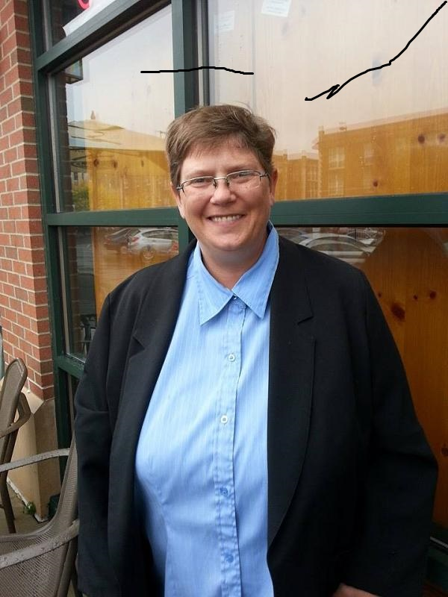

I became eligible for Medical Assistance (MA) and the waiver services after I spent my entire 401K on medical bills. It was terrifying losing the financial security I had built up from 30 years of working. I used to love my large mocha latte from Caribou, now for that same money I buy a loaf of bread, gallon of milk and jar of peanut butter for a week’s worth of lunches.

I’m thankful for the MA waiver services that help me live independently. Without my ILS worker and medication management nurse I could not manage to live fully and completely. I survive with the help of friends, food shelves, thrift stores and perseverance.

Here’s why the MA income and asset standards need to be increased. I get $1,195/month from Social Security Disability but am expected to pay $466 for my medical and support services every month before MA starts paying. This is known as my “spend-down” to qualify for MA and waiver services.

I pay $500/month in rent and do household/outdoor chores in exchange for utilities. After paying my rent and MA spend-down I have $229 left of SSDI income to pay all my other bills. Most months I don’t have enough money to meet my basic needs.

I worked hard my whole life and should not be forced into deep poverty to get the help I need while I get back on my feet. I am trying to make a better life for myself and am working towards starting my own insurance business. But until I can earn a steady income I need the state’s help.

I went from a 6 figure income to $14,000 year and now feel like I am invisible. Please see me and others like me and raise the Medical Assistance income, assets and spend-down standards.

Thank you for listening to my story.

