 

**Advancing Independence of People with Disabilities: Fix the Spenddown**

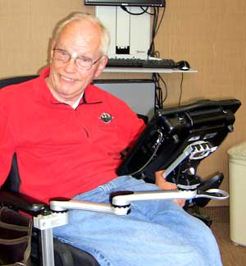Acute poverty looms just “over the hill” for me, an 80 year old tax accountant, who wants to retire without being forced into a dire hardship case. I currently serve the taxpaying public using the work incentive program called Medical Assistance for Employed People with Disabilities (MA-EPD). While on this program receiving earnings, I’m allowed to keep most of my income and just pay a monthly premium to receive Medical Assistance (MA) including attendant care. **These employment and health benefits are essential to my independence** and have allowed me to accumulate a comparatively small retirement fund, build a wheelchair size home and purchase an accessible vehicle.

However, if I stop working I will no longer be eligible for the MA-EPD program**. The only way that I would be able to receive vital services like attendant care through MA is to meet the current income and asset limits for people with disabilities on MA. This means that I would be forced to live at 80% of poverty level, or $792 per month**. **I would only be allowed to have $3,000 in cash assets including retirement plans, savings and checking accounts and loose cash.**

Living on $792 per month with very little cash reserves would not allow me to afford the real estate taxes, insurance and upkeep on my home and vehicle. **If I retire, I would soon be living in public housing, riding on state subsidized Metro Mobility, and shopping with government food stamps**. I have worked hard during my life and I want and deserve the opportunity to retire without being driven into poverty.

It is perplexing to comprehend why state policymakers support education, rehabilitation and employment for people with disabilities but then deny them the fruits of their labor when they retire. It is an injustice to discontinue these health benefits for retired people with disabilities who received them while on MA-EPD, especially since much more effort is involved in their work activities.

Policymakers say they want to keep elderly people with disabilities in their homes and engaged in the community because it is better for their overall health and saves taxpayers money. This can only be accomplished by taking the legislative measures necessary to extend eligibility to the poverty level and to raise asset level exclusions for disabled people of retirement age**. Please fund HF 225 so I can keep enough of my social security income and savings to live independently with dignity after I retire.**