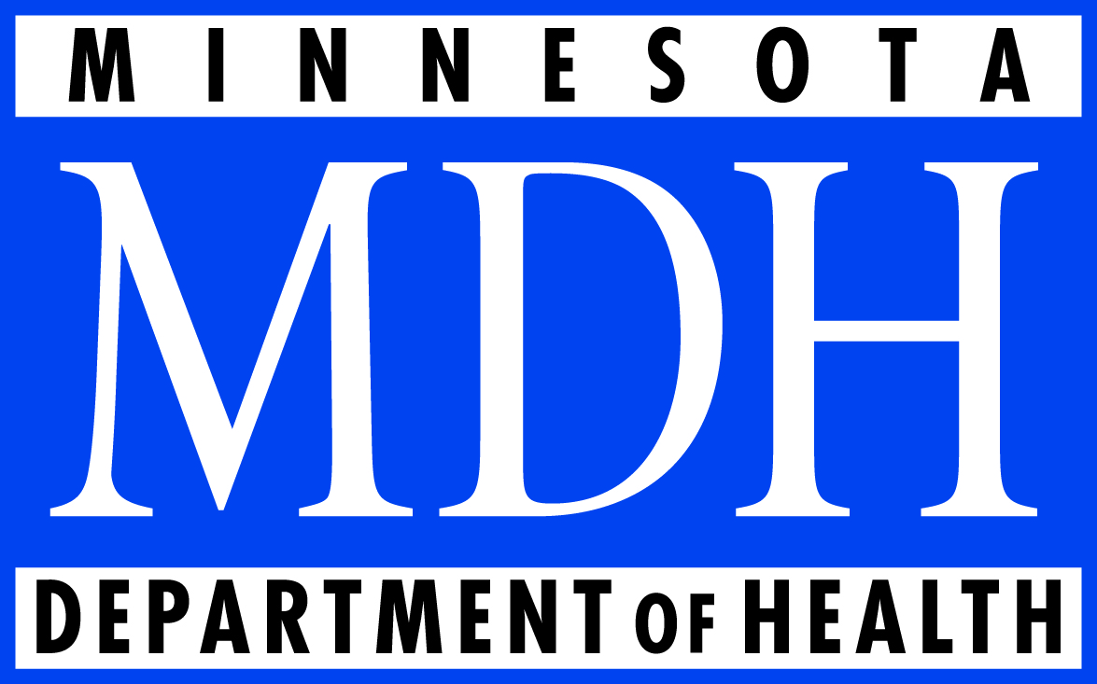
Minnesota Department of Health
PO Box 64975
St. Paul, MN 55164-0975
651-201-5000

Minnesota Department of Health
Mission: To protect, maintain and improve the health of all Minnesotans.

Minnesota’s public health system is known as one of the best in the nation. It is built upon a strong partnership between MDH, local public health agencies, tribal governments and a range of other organizations.

Some of the Areas Covered by MDH:
- Birth and death records
- Foodborne Disease Outbreaks
- Infectious Diseases Investigations
- Health Care Homes
- Health Statistics / Data
- HMO Regulation
- Immunizations
- Newborn Screening
- Public Health Lab
- Women, Infants and Children (WIC) Nutrition Assistance

Inspections:
- Assisted Living Facilities
- Community Water Supplies
- Funeral Homes
- Lodging / Camping
- Mobile Home Parks
- Nursing Homes
- Pools
“Public Health is what we, as a society, do collectively to assure the conditions in which people can be healthy.”
- Institute of Medicine

- Restaurants

Licensing:
- Body Art Establishments/Professionals
- Occupational Therapy Practitioners
- Environmental Lab Accreditation
(Most health occupation licensing is done through the health licensing boards)

Some of the services provided MDH:
- Assurance that inappropriate care in nursing homes, hospitals and other care facilities is corrected.
- Hospital and health care system planning to provide care for large numbers of injured or ill victims in a large scale emergency situation.
- Planning to help ensure rural Minnesotans have access to care.
- Quality measurement and public reporting of clinical care.
- Statewide health improvements that encourage people to make healthy choices.
- Efforts to eliminate health disparities between Minnesota’s different ethnic populations.
- Advice about reducing environmental and pollution risks to health.

