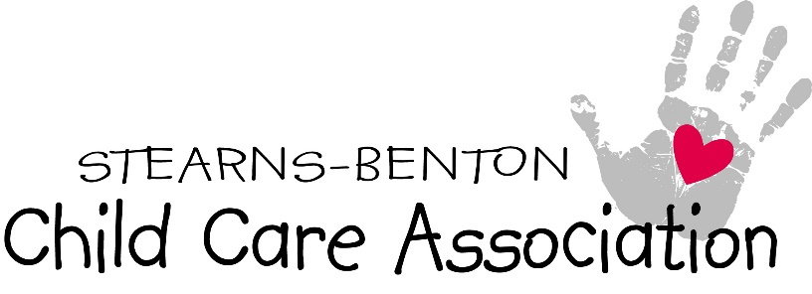
March 1, 2019
Dear Members of the House of Representatives,
When Providers get correction orders, conditional license, fines, or any other unclear issues that can not be resolved through discussion with licensing, this is where there is a need for the Ombudsperson.
When a person gets pulled over by a police officer and gets a speeding ticket, that person has the option to go in front of a judge (third party person) to plea a case. DHS is judge, jury, and prosecution. Child Care Providers need this separate entity.
Child Care Providers have had to reach out to law makers to intervene between providers and DHS. Even though it’s been very successful it’s truly not you job. Having an Ombudsperson would give us that option.
We are in support of HF 1665.

Thank you,
Kelly Martini - President
Stearns Benton Child Care Association
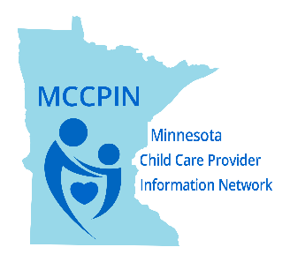
Linda Schesso - President

