

About MSCOD: The Minnesota State Council on Disability (MSCOD) was established in 1973 to advise the governor, state agencies, state legislature, and the public on disability policy. MSCOD advocates for policies and programs that advance the rights of Minnesotans with disabilities.

BACKGROUND OF BUDGET REQUEST:
MSCOD serves as a vital resource for Minnesotans seeking technical guidance on physical and digital accessibility. For decades, these individuals have been able to save millions in avoiding liability from ADA lawsuits and, more importantly, have built more accessible communities in every corner of the State. Unfortunately, our funding has consistently been piecemeal and unstable, as evidenced in Figure 1.

Figure 1: MSCOD funding sources

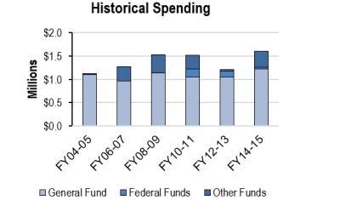
Source: MMB
Our budget request for FY18-19 focuses on stabilizing funding to maintain our ability to assist the people of Minnesota and anticipate turnover within our agency. It also addresses the fact that, to maintain programming, we have deferred basic investments in our agency.
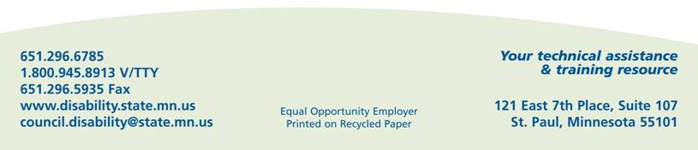
SUMMARY OF BUDGET REQUEST:
Structural Requests
- Furniture: The last time MSCOD received new office furniture was in 2009 and even that was an acquisition of used furniture. It has begun to pose workers compensation concerns and begun to affect our ability to accommodate agency stakeholders. Biennial cost: $76,000
- Rent increase and accessibility improvements: As the State’s resource on accessibility, MSCOD feels obligated to model an accessible workplace, especially given that the majority of our employees are people with disability. Basic structural constraints inhibit our ability to do that, and we are requesting funds to provide the type of workplace we are obligated to have. Biennial cost: $115,000

Staffing
Even 26 years after the passage of the Americans with Disabilities, the need to ensure accessibility for all Minnesotans is as pressing as ever. MSCOD plays a key role in informing and promoting that accessibility. To that end, we are including the following staffing requests.
- Digital Communications Coordinator (.37 FTE): Our Digital Communications Coordinator plays a key role in helping the State of Minnesota meet its obligations to blind and low-vision Minnesotans. This position has been funded on a temporary basis, for the past 3 years. Labor contracts dictate that the position must now be permanently added to our base.
Biennial cost: $44,000
- ADA Coordinator (1.0 FTE): In 2016, MSCOD received one-time funds through the Department of Labor and Industry to increase education and outreach to businesses around the State on issues of accessibility. The response has been overwhelming and we must continue this work. Biennial cost: $182,000
- Document Remediation Specialist (0.5 FTE): Our Digital Communications Coordinator’s time is increasingly taken up by consulting with other agencies and a major need exists to support MSCOD’s efforts to remediate documents themselves. Biennial cost: $90,000
- Accessibility Specialist Succession (0.5 FTE): The Minnesota Management and Budget Office has provided agencies with protocol for retaining institutional knowledge, as the current generation of state workers begin to retire. A Pro Plan enables an employee to stay on part-time as a consultant to pass on institutional knowledge. The individual occupying this position is the only person in this classification, in the entire State of Minnesota. Biennial cost: Pro Plan $129,000 One-time retirement buyout $18,000

