The Veterans Defense Project

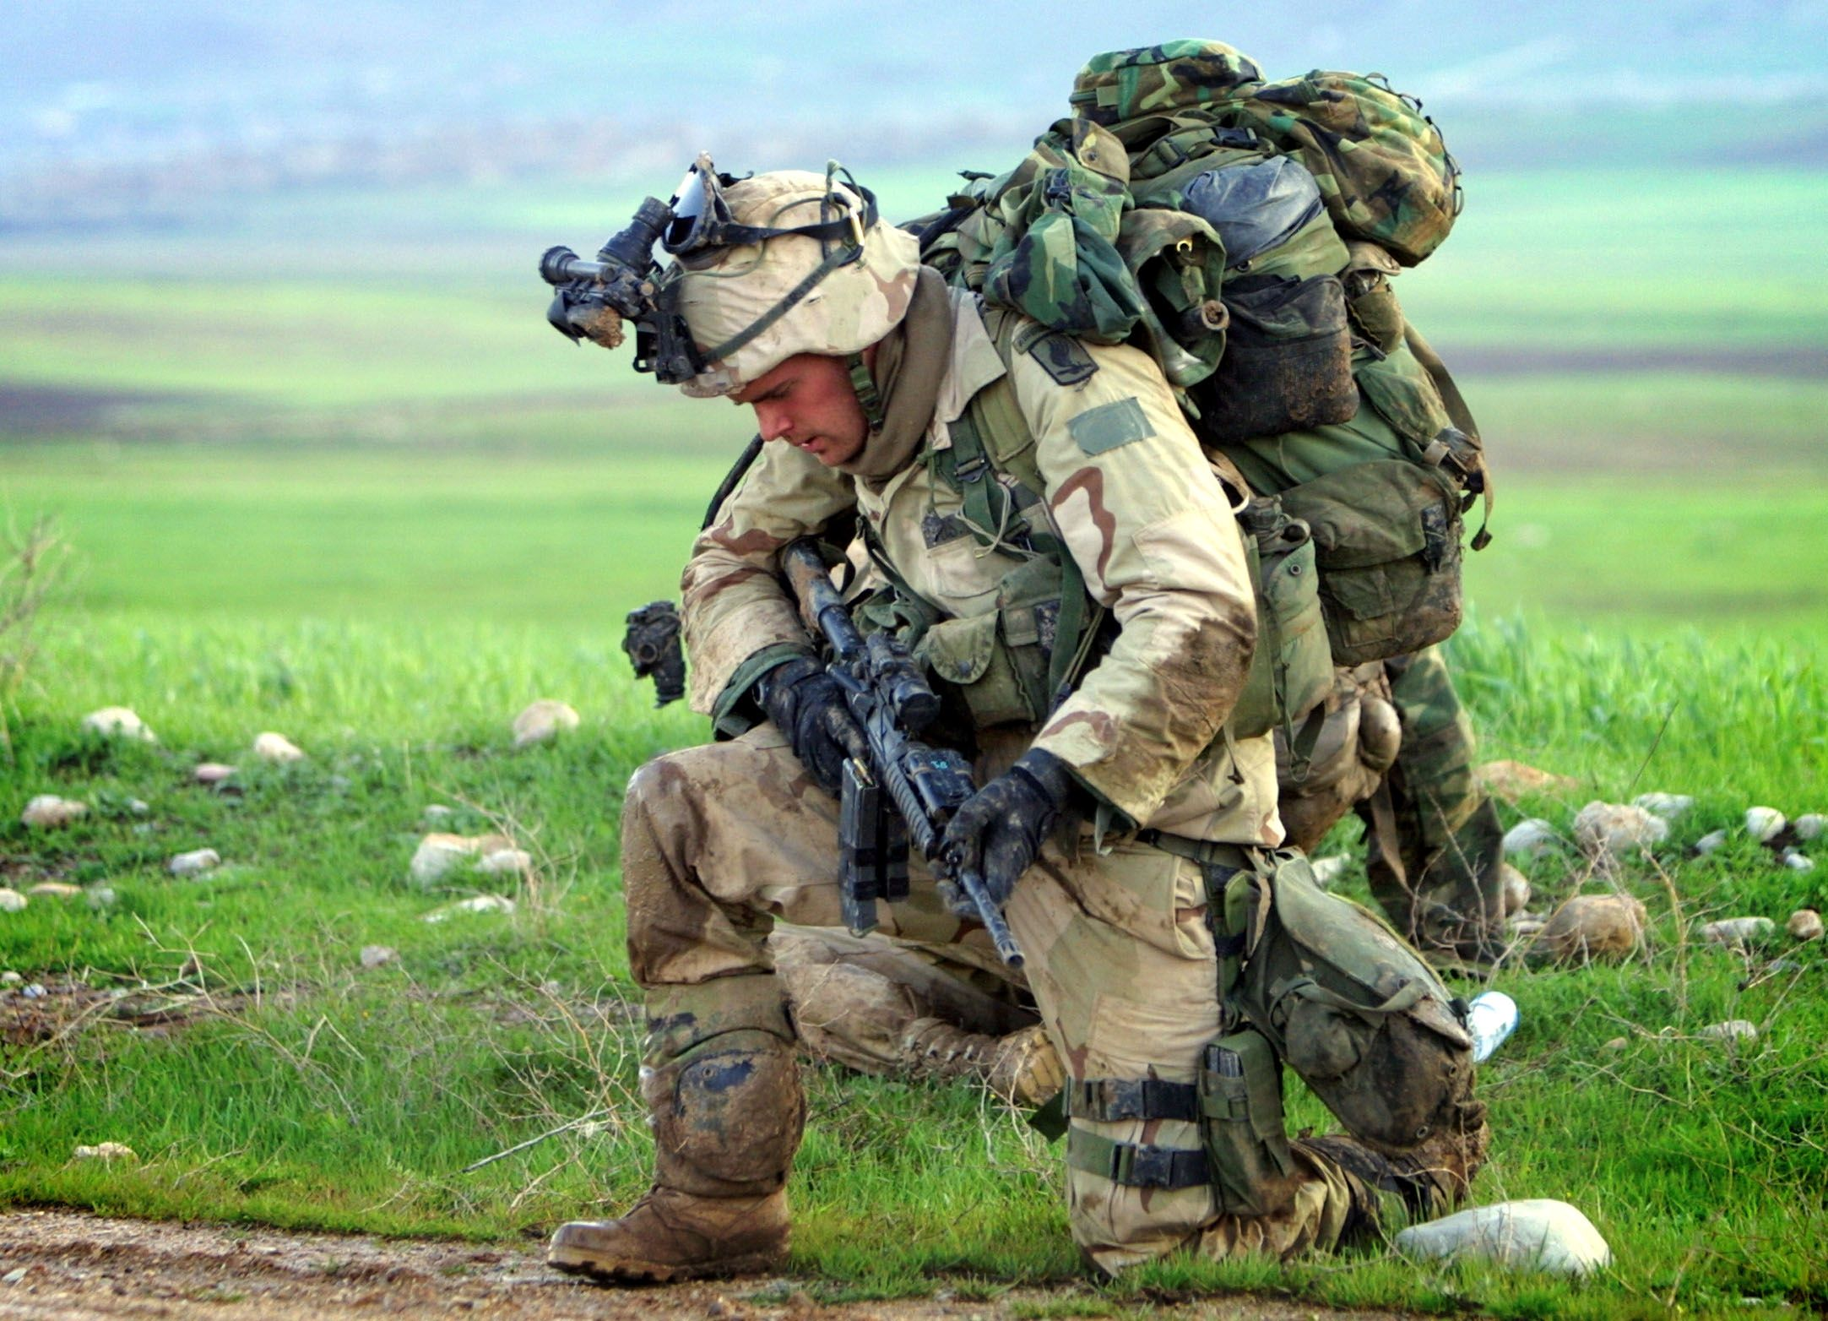

As the wars in Iraq and Afghanistan wind down, the majority of our new generation of veterans are returning home stronger and wiser from their service — becoming immediate assets to their communities. Many others, however, are bringing their wars home with them, silently suffering from invisible injuries.

More than 2.6 million Americans have now served in Iraq or Afghanistan. A U.S. government study, released in July 2012 estimated that up to 20%, approximately 500,000 of these veterans are suffering from Post Traumatic Stress Disorder (PTSD), and a similar number of these veterans are suffering from Traumatic Brain Injury (TBI). The same study also concluded that less than half of these PTSD or TBI-suffering veterans had previously reported or sought help for their condition, and that the true numbers are likely higher.

Untreated, many of these psychologically injured veterans are acting out in reckless, self-destructive and, sometimes violent ways, victimizing the very communities and individuals they were once willing to sacrifice their lives to protect. History tells us that the numbers of troubled veterans flooding into our criminal courts will continue to swell. A study of Vietnam veterans receiving care for PTSD in the VA system during the mid-1980’s found that almost half of all Vietnam veterans suffering from PTSD had been arrested at least once, 34.2% more than once, and 11.5% reported being convicted of a felony. Moreover, Vietnam veterans’ involvement in the criminal justice system has lingered for decades. A 1998 Department of Justice study found that, more than 20 years after the war, approximately a quarter million Vietnam veterans were still housed in our nation’s prisons.

The question we now face in criminal courts across the United States, including Minnesota, is what to do with this generation’s veterans, whose criminal offenses are tied to their untreated psychological war injuries and related addictions? Do we repeat the mistakes of the past, demonizing and discarding this generation as we often did earlier generations of troubled war veterans, especially after Vietnam? Or do we pursue a more informed approach: harnessing our newfound knowledge of combat trauma to use a criminal justice contact as an intervention opportunity to ensure troubled veterans receive the help they need to become assets to their communities, while better protecting public safety?

The Veterans Defense Project (VDP) is a Minnesota-based nonprofit organization, dedicated to educating, advocating and providing legal assistance for veterans in the criminal justice system. The VDP’s founders, Brockton D. Hunter and Ryan C. Else, are lawyers and military veterans, themselves, who have built a national reputation fighting for veterans in the justice system, including:

- Defending many high-profile veterans criminal cases;
- Leading passage of veteran sentencing legislation in many states, including Minnesota’s pioneering 609.115, Subd. 10, which was later cited by the U.S. Supreme Court in the landmark case, Porter v. McCollum, 558 U.S. 30 (2009), the first case from the highest court to require that combat trauma be considered in criminal sentencing;
- Co-Authoring and editing The Attorney’s Guide to Defending Veterans in Criminal Court, the only comprehensive legal treatise on this subject;
- Briefing the leadership of the Departments of Defense and Veterans Affairs, and training thousands of attorneys, judges, prosecutors, law enforcement and mental health professionals on doing a better job with veterans in the criminal justice system.

Through these public education efforts, the VDP thrust a lightning rod up into a growing storm. Calls for assistance from veterans and their families come into the VDP daily and their numbers are growing. Requests for training and consultation from courts and attorneys have also grown exponentially, far exceeding the VDP’s original scope and limited budget. The funding sought through this grant will allow the VDP to expand it capacity to meet the ever-growing demand for its vital services.

To learn more about the Veterans Defense Project, visit our web site at www.veteransdefenseproject.org.

Institute of Medicine of the National Academies, Treatment for Posttraumatic Stress Disorder in Military and Veteran Populations: Initial Assessment 39 (2012).
Id.
Richard Kulka, et al., National Vietnam Veterans Readjustment Study, VII-21-1 (1990).
Christopher J. Mumola, Bureau of Justice Statistics, Veterans in Prison or Jail, NCJ 178888 (2000), http://www.ojp.usdoj.gov/bjs/.

