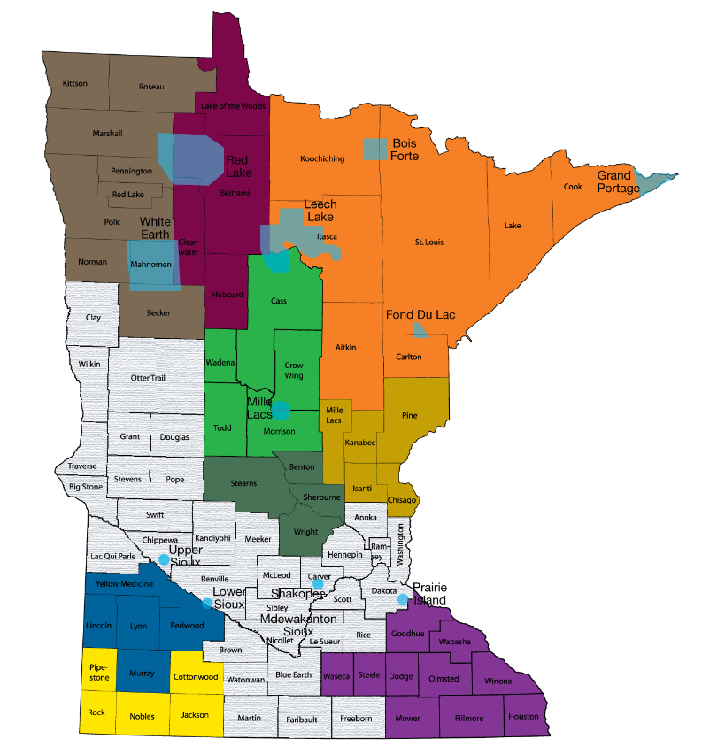

Note:
- Light blue areas denote the Tribal Nations. TXT4Life serves all Tribal Nations.
- Colored shading shows areas where TXT4Life Coordinators are funded and available.
- Grey areas indicate areas that available for expansion.
- Individual colors denote specific coverage areas by individual TXT4Life Regional Coordinators

