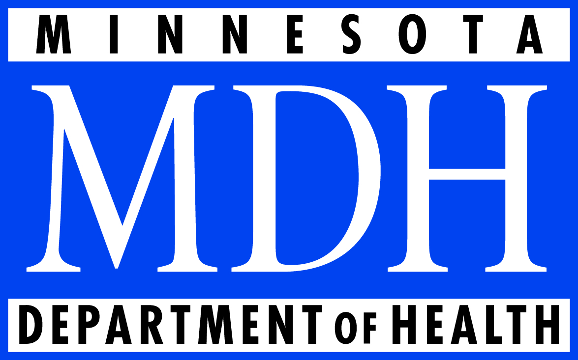
Office of Rural Health and Primary Care
P.O. Box 64882
St. Paul, MN 55164-0882
651-201-3838
www.health.state.mn.us/orhpc

Loan Forgiveness Program

Loan Forgiveness Program
Minnesota’s Loan Forgiveness program has been evaluated twice in recent years, once in 1999 and again in 2007. Both evaluations describe an effective program that meets its goals of recruiting providers to underserved areas, and that is an influential factor in recipients’ decision of where to practice after graduation.
Most participants reported loan forgiveness was important to very important in influencing their decision to practice in a rural or underserved area.

State loan forgiveness programs, with budgets from $90K - $35 million, have 26,000 participants nationally. According to a national study, “state [Loan Forgiveness] programs bring physicians to needy communities where they find satisfying work and remain for many years,” and retention outcomes for loan forgiveness are better than other incentives such as scholarships or stipends.

Recipient Data
Minnesota’s Loan Forgiveness program dates back to 1992, and has changed over the years to include new provider types, and various levels of funding. Here is ten fiscal years of data outlining the funding by source, and the number of new awards:

 | 2015 | 2014 | 2013 | 2012 | 2011 | 2010 | 2009 | 2008 | 2007 | 2006
Appropriations (1,000s)
Health Care Access Fund | 740 | 740 | 740 | 740 | 740 | 740 | 740 | 740 | 740 | 740
Board of Nursing SGSR |  |  |  |  | 200 | 200 | 200 | 200 | 200 | 125
Board of Medical Practice SGSR |  |  |  |  | 200 | 200 | 200 | 200 | 200 | 200
Loan Forgiveness GF |  |  |  |  | 155 | 155 | 155 | 155 | 155 | 95
MMA Foundation | 50 | 50 | 50 | 50 |  |  | 50
Total Loan Forgiveness Funding | 790 | 790 | 790 | 790 | 1,295 | 1,295 | 1,345 | 1,295 | 1,295 | 1,160
Number of New Awards | 16 | 18 | 16 | 23 | 28 | 22 | 36 | 35 | 48 | 46

New Findings
In the summer of 2014, MDH evaluated retention data for the program. MDH used program data, licensing board data, and in certain cases survey data to verify practice site for recipients of the program. Past recipients were tallied based on whether their current practice site would still qualify them for the program. The timeframes are the number of years after completion of program requirements.
Rural Physician  Loan Forgiveness Program | 5 Years (FY10-14) | 10 Years (FY04-14) | 15 Years (FY00-14) | 20 Years (FY94-14) | 20+ Years (FY91-14)
Stayed in rural community by original definition of rural area | 88.9% (8) | 87.9% (36) | 78.3% (94) | 73.5% (125) | 74.5% (149)
Participants | 9 | 41 | 120 | 170 | 192
Rural MidLevel  Loan Forgiveness Program | 5 Years (FY10-14) | 10 Years (FY04-14) | 15 Years (FY00-14) | 20 Years (FY94-14)
Stayed in rural community by original definition of rural area | 100% (5) | 93.1% (27) | 71.6% (48) | 70.2% (80)
Participants | 5 | 29 | 67 | 114

Rural Pharmacist Loan Forgiveness Program | 5 Years (FY10-14) | 8 Years (FY06-14)
Stayed in rural community by original definition of rural area | 80% (8) | 84.2% (32)
Participants | 10 | 38
Nurse  Loan Forgiveness Program | 5 Years (FY10-14) | 10 Years (FY04-14) | 15 Years (FY00-14) | 20 Years (F94-14)
Stayed in Licensed Nursing Home or Independent Care Facility | N/A | 73.7% (14) | 69.7 % (23) | 56.7% (38)
Participants who responded to the MDH survey | 0 | 19 | 33 | 67
Dentist  Loan Forgiveness Program | 5 Years (FY10-14) | 10 Years (FY04-14) | 12 Years (FY02-14)
Active MN License and Practicing, offering Public Assistance | 66.7% (4) | 51.6% (16) | 51.7%(31)
Participants | 6 | 31 | 60
Nurse and Allied Health Faculty  Loan Forgiveness Program | 5 Years (FY10-14) | 10 Years (FY04-14)
Teaching Nursing/Allied Health in a MN University/College Setting | 100% (8) | 76.6% (36)
Participants | 8 | 47

Both evaluations are available at: http://www.health.state.mn.us/divs/orhpc/funding/loans/index.html
Pathman et al, Medical Care 2004 42: 560-568

