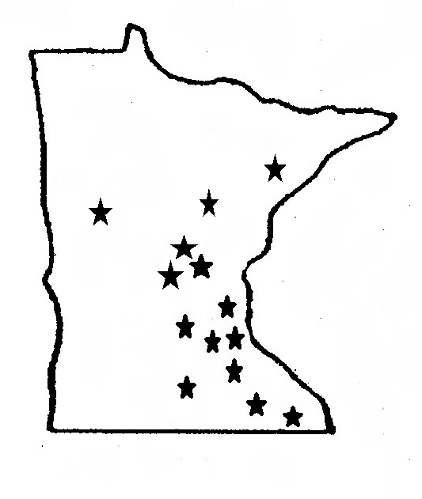
minnesota inter-county association
161 st. anthony ave • suite 850 • st. paul, mn 55103 • (651)222-8737
website: www.mica.org • email: mail@mica.org
benton·blue earth·carver·crow wing·dakota·olmsted·otter tail·rice·st. louis·scott·sherburne·stearns·washington·winona

Alternative Investments of City and County Funds under HF 409

HF 409 would allow 1) cities and counties over 100,000 population , 2)smaller cities and counties that have demonstrated their superior financial management through attainment of a AAA bond rating (all listed below), and 3) self insurance pools of the counties, cities, townships and school districts to invest in a very narrow range of equity investments. The qualifying cities and counties investments would be allowed for a limited set of long-range purposes including:

- long-term capital plans,
- funds held to offset long-term environmental exposure,
- other postemployment benefit liabilities,
- compensated absences, and
- other long-term obligations established by applicable accounting standards

The long range purposes either 1) comport to recent changes in governmental accounting standards, GASB 34, 45, 67 and 68, which have changed from pay-as-you-go accounting for some of these costs to one that identifies the cost of these liabilities as they accrue or 2) state requirements to set-aside monies for closure and post-closure costs for landfills.

County | 2015 Population | Most Recent Bond Rating
Hennepin | 1,210,720 | AAA
Ramsey | 529,506 | AAA
Dakota | 411,507 | AA+
Anoka | 342,612 | Aa1
Washington | 249,109 | AAA
St. Louis | 200,840 | AA+
Stearns | 153,326 | AA+
Olmsted | 150,201 | AAA
Scott | 138,727 | AAA
Wright | 129,946 | AA+
City | 2015 Population | Most Recent Bond Rating
Minneapolis | 411,273 | AA1 Moody's AAA S&P
St. Paul | 299,641 | AAA
Rochester | 111,007 | AAA
Bloomington | 87,224 | AAA
Plymouth | 74,592 | AAA
Eagan | 67,509 | AAA
Eden Prairie | 63,187 | AAA
Burnsville | 61,908 | AAA
Mnnetonka | 51,647 | AAA
Edina | 50,766 | AAA
Apple Valley | 50,161 | AAA
Roseville | 35,244 | AAA
Golden Valley | 21,571 | AAA
Orono | 7,474 | AAA
Wayzata | 4,564 | AAA

The expanded authority is limited to:

mutual funds indexed to the S&P 500 or the Dow Jones US Total Stock Market Index

with the State Board of Investment (SBI)

The SBI’s role as one conduit for these limited equity investments would have PERA performing the administrative tasks. PERA already performs this role for local government investments with SBI for other Post Employment Benefit Trusts. Both entities would be compensated for their costs under the bill

SBI already serves as investment conduit again with PERA performing the administrative tasks for at least 22 local governments – 21 through the Other Post Employment Benefit (OPEB) Account (four of which are in the 25 entities above) and one (also in the 25 above) through the St. Louis County Environmental Trust. The City of Duluth has both monies invested in the OPEB account as well as in the separate Duluth Community Investment Trust. The SBI currently has:

$523 million under management for the OPEB account and as of the end on 2016 the equities portion of that investment for just the city of Duluth provided 1 year returns of 4%, 3 year returns of 11.7% and 5 year returns of 12.1%.

$12.8 million for the St. Louis County Environmental Trust, and

$19.7 million for the Duluth Community Investment Trust

The authorized cities and counties can invest no more than 15% of their unassigned funds in the limited equity investments allowed under the bill.

