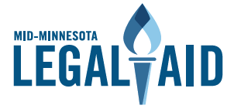
Legal Services Advocacy Project

HF 815 / SF 665
Assignment of Military Pay/Benefits – Technical Fix
Authors
- House: Rep. Matt Bliss (chief); Chair Jerry Newton (co-author).
- Senate: Sen. Bruce Anderson (chief); Chair Erin Murphy and Sen. Andrew Lang (co-authors)

Background
- In 2018, the Minnesota Legislature passed a bill that prohibits predatory lending practices perpetrated against military servicemembers and veterans.

- Specifically, the bill, signed into law, prohibited the practice of lending upfront cash to servicemembers and veterans in exchange for the servicemember or veteran signing away (assigning) rights to their pay or future benefits (e.g., pension).

- The bill provided for remedies for the victimized servicemember or veteran to go to court and get attorney fees and costs.

The Problem
- The intent of the remedies section was to provide BOTH legal (monetary compensation) AND equitable relief (e.g., injunction, rescission of the contract)

- Somehow, the language of the final bill read legal OR equitable relief.

- If victimized, a servicemember or veteran should not have to choose one or the other; they should be – and the intent of the original bill was they would be – entitled to BOTH legal and equitable remedies.

What the Bill Does
- Changes the “or” to and “and”

Supporters: Legal Aid
Opponents: None

The 2018 bill was authored by the same authors as HF 815 / SF 665: Rep. Matt Bliss & Sen. Bruce Anderson, respectively.

