March 14, 2016

Health and Human Services Reform Committee
Minnesota House of Representatives
175 State Office Building
Saint Paul, MN 55155

Dear Chair Mack and Members of the Health and Human Services Reform Committee,

Gillette Children’s Specialty Healthcare (“Gillette”) supports HF 2344, the Orthotists, Prosthetists and Pedorthists Licensure Bill because of the protection that it provides to our patients.

Gillette provides assistive technology services for children, teens and adults who have disabilities and complex conditions that began during childhood. Whether a patient has a lifelong condition, such as cerebral palsy, or experiences a traumatic injury, our certified orthotists and prosthetists collaborate with Gillette therapists and other specialists to support our comprehensive care model and design custom solutions for each patient’s needs.

As an organization whose mission relies heavily on our employment of orthotists, prosthetists and pedorthists, we support this bill. The establishment of minimal standards of education and training required for professional competency will help to ensure the highest quality of care for Gillette patients. We ask for your support of HF 2344.

Sincerely,

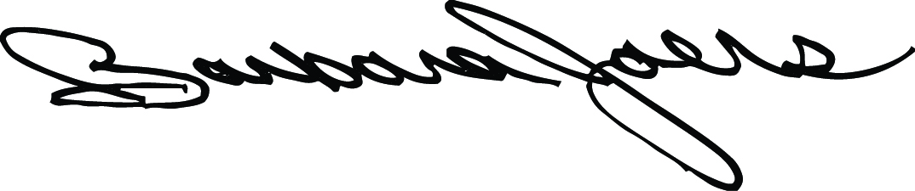
Barbara Joers
President and CEO

