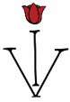
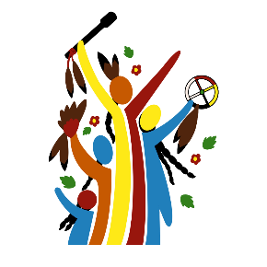
Indigenous Visioning

Indigenous Parent Leadership Initiative
P.O. Box 148
Bagley MN 56621
www.IndigenousVisioning.com

March 23, 2023
Dear Chair Liebling and Members of the Committee,

On behalf of Indigenous Visioning and All Nations Rise, we want to thank the Governor and Lt. Governor for including the Community Solutions for Healthy Child Development Grant Program in their Department of Health budget bill SF 2995 and encourages the committee to follow suit by including SF402 in the Senate Health and Human Services Omnibus budget bill. This historic program focuses on improving measures of well-being for children of color and American Indian children in Minnesota prenatal to grade 3 through a community and equity-centered approach across the state.

It is historical because the grant program is guided by a Community Solutions Advisory (CSA) Council comprised of 12 community members who bring professional expertise and lived experience in racial equity, early childhood development and advocacy. The council has been involved from the beginning of the grant program from RFP creation, reading and scoring applications, and ongoing support and advocacy for more streamlined implementation and processes.

As a grantee, we want you to know about the positive impact that Community Solutions funding has brought to the White Earth Ojibwe Nation tribal community through the creation of the Indigenous Parent Leadership Initiative (IPLI). IPLI is a 21 week journey that integrates child development, leadership, democracy skills and Anishinaabe culture into a parent curriculum to empower the parent voice. Through interactive adult learning practices, twenty-two Parents, Grandparents, Foster Parents and Caregivers in the White Earth tribal community learned the importance of the developing child and how local, state and tribal policies and systems affect children & families through a nationally accredited evidence based civics curriculum. Parents create individual community projects to practice their civic and cultural teachings and help strengthen their leadership skills. IPLI is the first of its kind in Minnesota and White Earth is the second tribal nation in the United States to implement the Parent Leadership Training Institute curriculum. The initiative inspires parents to become empowered to use their voice as change agents and be role models for their children while bringing about positive change within their own lives, their children’s lives and the health of their tribal communities.

“This 21 weeks of the Indigenous Parent Leadership Initiative has been challenging but there comes growth with that. I feel confidence now after learning how to use my voice and build community. It was a blessing getting to know everyone and learning how to network. Everyone is so resourceful! I am grateful!”
~Autumn Oppegard 2022 Graduate

“The Indigenous Parent Leadership Initiative has really changed my life for the better and given me more opportunities to learn and lead as a parent in my tribal community. I look forward to the future and seeing more parents in my tribal community experience this process and become parent leaders.”
~Mykee Brown, 2023 Graduate

We hope you will join the Governor and Lt. Governor in giving this innovative program the permanent funding needed to fully deliver on its promise (SF402). Minnesota has the need and Minnesota has the resources. We need to continue this leverage more community led solutions beyond the pilot group of grantees as an upstream way to support children and families.

Miigwech (Thank you) for supporting children, families and communities.

Barb Fabre, CEO Beth Ann Dodds
Indigenous Visioning Project Director/IPLI
All Nations Rise Indigenous Visioning

