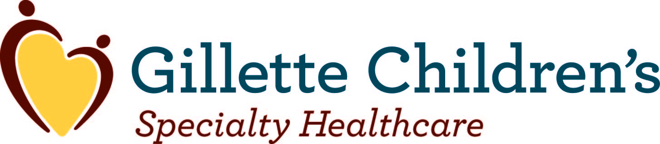

Role and History of DSH Payments:

- Disproportionate Share Hospital (DSH) payments were created by Congress in the 1980s to help mitigate losses incurred by hospitals that serve a large number of patients on Medicaid (Medical Assistance in Minnesota) and uninsured individuals.

- Children’s hospitals across the nation traditionally treat a large number of Medicaid patients.
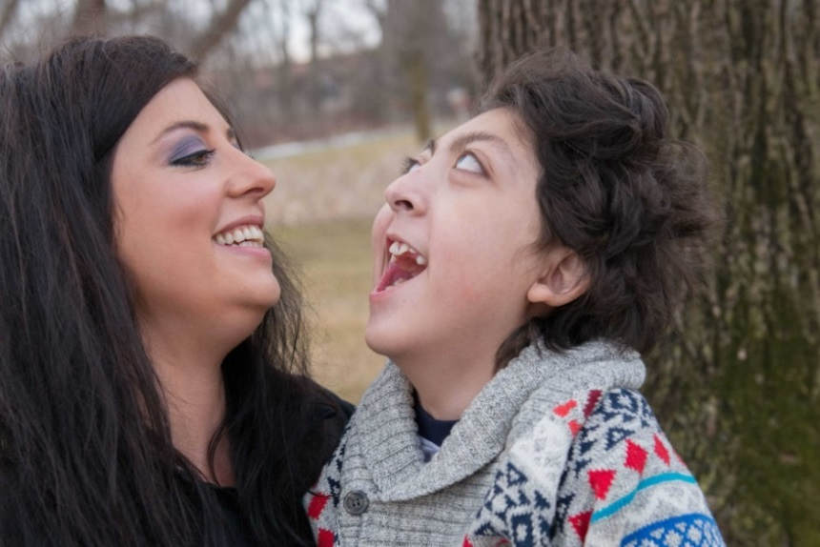
- Nearly 67 percent of all Gillette inpatient stays, based on 2012 data, are patients eligible for or covered under Medical Assistance.

- Many Gillette patients qualify for Medical Assistance not because of their family’s income, but due to the severity of their disability.

- Gillette treats patients who have highly complex conditions such as cerebral palsy, spina bifida and muscular dystrophy. Many of these families have private insurance coverage, which is their primary source of coverage, with Medical Assistance as a secondary source of coverage.
Javier of Shoreview, Minnesota, has cerebral palsy and epilepsy.

CMS Interpretation of Federal Law Changes DSH Calculation Methodology:

- States must submit annual DSH reports and independently certified DSH audits to the Centers for Medicare and Medicaid Services (CMS). The audits are completed three years retrospectively. In 2010, CMS implemented a new interpretation of federal law as part of an FAQ on its website. This new interpretation would require hospitals to include third-party payments (including private insurance payments) in their annual DSH audits for patients who are Medicaid eligible—even in instances where a hospital receives no Medicaid payments for that patient.

- The new CMS interpretation has harmed children’s hospitals across the U.S. because many of the patients children’s hospitals serve (including Gillette, as referenced above) have private insurance as their primary source of coverage and Medicaid as their secondary source of coverage. This interpretation does not accurately reflect the losses incurred by children’s hospitals treating large volumes of Medicaid and uninsured patients.

Impact on Gillette:

- Gillette stands to lose more than $26 million in DSH payments for the period of 2011-2016, and over $6 million in 2016 alone.

