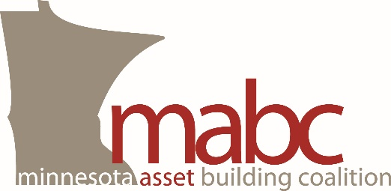
April 13, 2015

Re: HF 559 / SF 543

Dear Members of the Minnesota Legislature:

The Minnesota Asset Building Coalition (MABC) strongly supports HF 559 / SF543, which would increase the income eligibility limit, asset limits and excess income standards for Medical Assistance eligibility for elderly Minnesotans and Minnesotans with disabilities. Existing law unfairly disadvantages this population – consisting of Minnesota’s most vulnerable persons – by requiring them, unlike any other group, to spend down to 75% of the federal poverty level and exhaust precious assets in order to qualify for this critical health care program. HF 559 /SF 543 would rectify this disparate treatment.

The MABC is a coalition of 113 organizations across the state committed to creating opportunities for Minnesotans to achieve greater financial stability by building assets. The income and asset restrictions contained in current law impacting only elderly Minnesotans and Minnesotans with disabilities forces them to choose between necessary medical care and overall financial security and quality of life. Additionally, the current “spend-down” requirements can make it difficult for individuals to afford to live independently in their community rather than in an institutional care facility.

HF 559 / SF 543 would make it possible for individuals to retain their eligibility for Medical Assistance while building the financial assets necessary to maintain independence, survive financial setbacks, and prepare for a financially stable future. MABC urges passage of this important bill.

Sincerely,

Anna Odegaard
Legislative Advocate
Minnesota Asset Building Coalition

Smart asset building policies lead to more financially healthy households.

