Report to legislators on HF 778 (2015) Early Dental Prevention Initiative
Timeline | Progress
August 2015 - Present | 23 organizations supporting this initiative met 7 times to give advice and direction with the guidance of MDH and Community Dental Care (Steering Committee).
August 2015 - Present | Steering Committee has met 8 times to discuss the direction of implementing HF 778
May 2016 | Community Dental Care started a pilot project for children ages 0-2.
June-December 2016 | Advisory group and five work groups met on a periodic basis to conceptualize educational materials and a distribution plan. Multiple Focus Group Discussions were conducted and incentive was finalized. Community outreach events were organized and oral hygiene materials for infants and toddlers were distributed to communities of color and recent immigrants.
January 2017 | MDH hired Early Dental Disease Prevention Initiative (EDDPI) Coordinator.
January 2017 | MDH named the EDDPI campaign: "Healthy Teeth, Healthy Baby" based on focus group findings.
March 2017 | MDH designed and drafted oral health key messages for infants and toddlers in Somali, Hmong, Spanish and English languages for radio distribution to target communities.  The Public Service Announcement (PSA) will be broadcasted through noncommercial KFAI (90.3 FM, 106.7 FM) and KALY (101.7 FM) radio stations from March to June 2017.  These radio stations serve more than 100,000 diverse groups such as Somali, East African communities on a daily basis.
July 2017 - 2019 | Implementing HF1490 with 5 community dental clinics including at least 2 clinics in greater Minnesota and 3 in the metro area. (The data and experience from these clinics can help us develop a more complete preventive dental care and education for parents and babies.)

Early Dental Prevention Initiative Advisory Group
- HCMC Pediatric Clinic | - MN Department of Human Services | - National Children’s Oral Health Foundation
- Dept. of Pediatric. and Adolescent Medicine, Mayo Clinic Rochester | - Health East Roselawn | - MN Department of Health; Refugee Health
- U of M Medical Center, Fairview University | - Delta Dental of MN Foundation/ Community Affairs | - Ramsey County Public Health
- Park Dental | - Early Childhood Dental Network (ECDN) | - Children's Dental Services
- MN Oral Health Coalition | - Saint Paul Ramsey Co. Public Health | - IDEPC
- MN Department of Health-Oral Health Program | - U of M SOD, Div. of Pediatric Dentistry | - Community Dental Care
- United Therapy | - U of M SOD, Dental Primary Care/External Service Provider | - Hylden Advocacy and Law
- MN Department of Health-C&TC Program | - Ramsey County Home Visiting Nurses | - HealthPartners Pediatric Dentistry

Requests support for:

1. Prevention for Permanent Teeth Via School Base Dental Sealant Program (one of the modalities to prevent caries in permanent teeth for 6-10 year old)

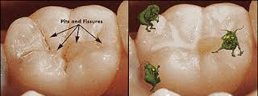
Before
After
Twelve of the 34 studies compared resin‐based sealants to no sealants and found that children who have their back teeth covered by a sealant are less likely to have dental decay in their back teeth than children without sealant. For example, if 40% of back teeth develop decay over a 2‐year period then the sealant reduces this to 6%. In another group of children where 70% of these back teeth would develop decay over a 2‐year period, using sealants reduces this to 19%. These results are based on data from six studies (five of which were published in the 1970s) where the children were aged 5 to 10 years when the sealants were placed. Similar benefits for resin‐based sealants were shown up to 9 years. https://www.ncbi.nlm.nih.gov/pubmedhealth/PMH0011213/

2. Prevention for Primary Teeth (Baby Teeth) Starting with Pilot Projects for Underserved Children

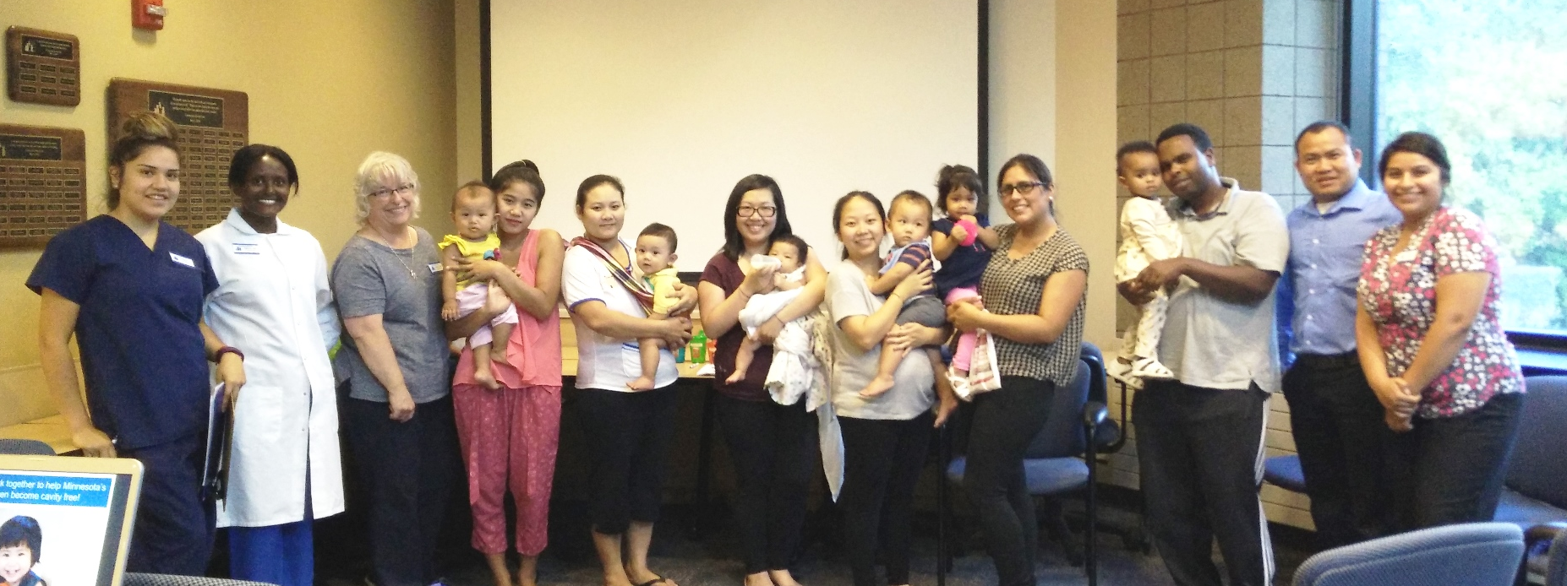

AAPD Guideline on Infant Oral Health Care: Early childhood caries (ECC) and the more severe form of ECC (S-ECC) can be particularly virulent forms of caries, beginning soon after tooth eruption, developing on smooth surfaces, progressing rapidly, and having a lasting detrimental impact on the dentition.4-9 This disease affects the general population but is 32 times more likely to occur in infants who are of low socioeconomic status, who consume a diet high in sugar, and whose mothers have a low education level. http://www.aapd.org/media/policies_guidelines/g_infantoralhealthcare.pdf

