**Minnesota is aging**

* Between 2010 and 2030, the number of people over age 65 will grow by 107% while the rest of the population grows by 6%.
* People over 65 have a 70% risk of needing long-term care at some point in their lives.
* Long-term care is help you receive with daily tasks such as bathing, dressing or house cleaning. The risk of needing this help increases with age.

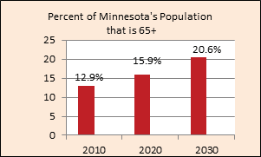

**Will there be enough family caregivers**

The vast majority of long-term care older people need is provided by unpaid family members, mainly spouses, partners and adult children.

* Families are smaller and most women now work full-time, thus reducing the number of family members available to provide care.
* When families and other unpaid caregivers are not available, individuals must pay agencies and facilities for the care they need.

**Many individuals are not prepared**

* Many boomers have not saved enough to pay for long-term care. In 2015, the Employee Benefit Research Institute found that 60 percent of workers have saved less than $25,000 for their retirement.
* Without additional private financing for long-term care, the state could see challenging increases in its elderly long-term care budget, rising from $1 billion in 2015 to nearly $4 billion in 2040.
* Paying for long-term care is expensive. The average annual costs of long-term care ($57,000) are roughly the same as median household income in Minnesota ($59,000).

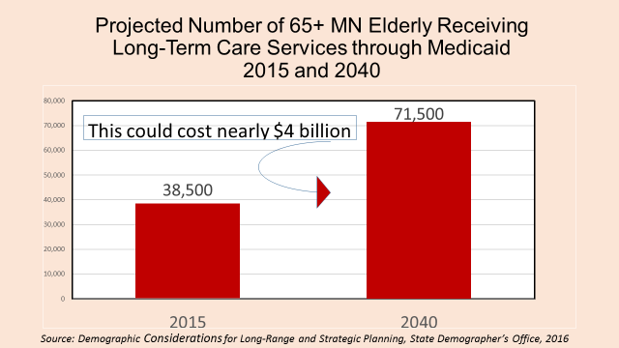

**Own Your Future**

Minnesota’s Own Your Future began in 2012 and includes three interlocking phases:

1. Implement a public awareness effort about the need to plan for long-term care. (2012 – present)
2. Identify more affordable insurance and financial products for use by middle-income households. (2013 – 2017)
3. Evaluate ways to change Medicaid to better incent private payment for long-term care. (2017 – 2018)

An Own Your Future advisory group worked throughout 2013 - 2014 to identify private financing concepts (see table below) to help middle-income households pay for long-term care. The group also made several overarching recommendations to support increased consumer education and information about long-term care planning and work more closely with employers on these issues. The group’s full report is available a[t http://mn.gov/ownyourfuture.](http://mn.gov/ownyourfuture)

**Product Concepts to Help Middle-Income Households Pay for Long-Term Care**

|  |  |  |  |  |
| --- | --- | --- | --- | --- |
| **Stimulate the long-term care insurance (LTCI) market** | **Change existing or new products to fill gaps in coverage** | **Modernize Medicare and related products** | **Improve access to and safety of home equity options** | **Increase use of tax-favored savings plans** |
| Encourage marketing of starter or transition LTCI plan | Work on state reciprocity for group and hybrid Partnership products | Study feasibility of including a long-term care (LTC) benefit in Medicare supplemental plans* | Make reforms in MN reverse mortgage laws to improve the market and consumer protections | Create new or modify existing Health Savings Account provisions to allow LTC use  LTC |
| Encourage marketing of streamlined basic LTCI plan | Further the development of a combo term insurance and LTCI product for life stage protection* | Consolidate the Medicare nursing facility, home health and hospice benefit into one LTC benefit | Support new options for accessing home equity for LTC | Modify provisions of tax-deferred savings plans to incent use for LTC expenses |
| Encourage marketing of high deductible catastrophic LTCI plan | Study pros/cons of establishing life settlement trust funds | Support the 2013 federal LTC Commission’s  recommendations on Medicare reforms |  |  |
| Study how a public LTCI option might work in MN | Study feasibility of new reinsurance options for LTCI market |  |  |  |

**\***Products with high potential to meet middle income household needs

**Next Steps in Product Development Work**

* Work with actuaries, carriers and others to determine the pricing of the two products with high potential.
* Gauge consumer interest in various financing options within middle-income market.
* Explore the interest of carriers and health plans in developing and marketing these products or modifications of these products.
* Engage with national and local stakeholders including legislators to discuss Own Your Future work.
* Summarize results from these steps and, if warranted, develop an action plan to move to the next level, e.g., product development by carriers, pilots to test the marketplace.