 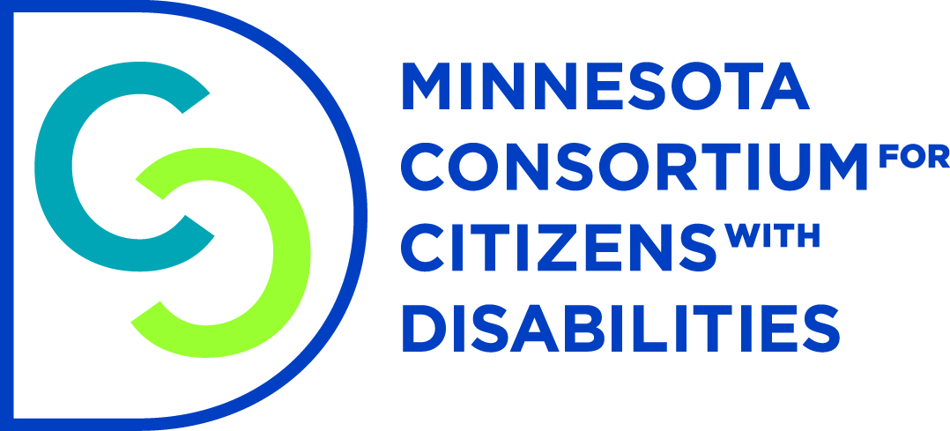

**Advancing Independence of People with Disabilities: Fix the Spenddown**

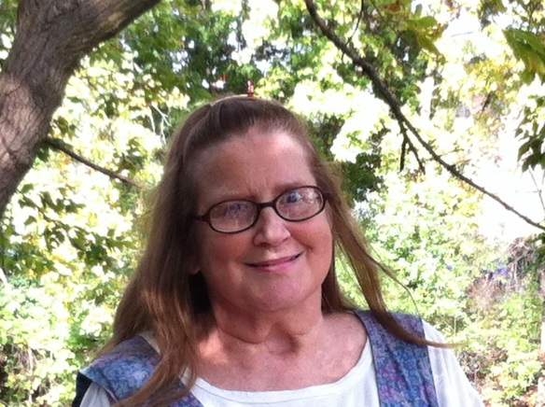 My name is Rebecca Preston and I live in Hopkins. I sustained a Traumatic Brain Injury in 2005 when I was T-Boned by a drunk driver.

Memory problems from my brain injury make it hard for me to concentrate and do simple things like pay my bills and interpret my mail.

I’m grateful for the help of the Medical Assistance Waiver Program. My Independent Living Skills worker helps me stay organized and independent in my own apartment, which is something I never thought I would be able to do again.

I receive about $1,000 dollars/ month from Social Security Disability Insurance which I paid into while working two jobs before my brain injury.

**I’m expected to pay almost $300 of my medical bills each month before MA starts paying**. This is known as my Spend-down. After paying my rent and spenddown I have $70 dollars left to pay all my other bills.

It feels like I’m being penalized for working hard my whole life and paying into Social Security. **To make ends meet I rely on food shelves with mostly unhealthy food choices.**

It makes no sense that I am expected to live below the poverty level to get the help I need to stay independent. **Please fix the spenddown so I can keep more of my own social security income to pay my bills, afford healthy food, and stay independent.**

**Please Fund HF 225**