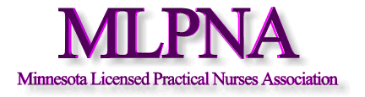

February 17, 2015

Rep. Sarah Anderson
583 State Office Building
100 Rev. Dr. Martin Luther King Jr. Blvd.
Saint Paul, Minnesota 55155

Dear Rep. Anderson,

We want to thank you for authoring the Healthy Eating, Here at Home legislation (SF316). As the association representing licensed practical nurses throughout Minnesota, we understand that healthy eating and good nutrition lead to better health outcomes and reduces the risk of obesity-related conditions such as type-2 diabetes, clogged arteries and thyroid dysfunction.

When you eat a balanced diet including whole grains, lean meats, low-fat dairy products, and fruits and vegetables, your body has the fuel that it needs to manage your energy level. We have an epidemic of childhood obesity in the United States with one out of five children overweight or obese by the time they start school. In Minnesota, children in families that are on public insurance are two times more likely to be overweight than those on private insurance so the earlier we can teach children about the benefits of healthy eating and provide access to these foods, the better!

We think allowing low-income Minnesotans to use their Supplemental Nutrition Assistance Progran (SNAP) benefits just makes sense! When healthy options are easily accessible in our communities we’re much more likely to make healthy choices. Thank you for providing an avenue for low-income Minnesotans to access healthy foods for their families.

Sincerely,

Deb Tauer, President
Minnesota Licensed Practical Nurses Association

