February 12, 2020

Dear Committee Members,

I am unfortunately not able to make it to the committee meeting tomorrow, but I wanted to send you a short letter to share that the Minnesota Council on Foundations is in support of HF 3068.

The philanthropic and nonprofit sector is nonpartisan. This is a point of pride, and it is also a matter of law. Under the Johnson Amendment in federal law, nonprofits are not allowed to endorse or oppose candidates or fund campaigns or political parties. The current lack of voter privacy protections for the March 3rd presidential primary threatens the nonpartisan nature of the sector. If party preferences became public, there is a concern that the party preferences of sector leaders could be revealed in a harassing manner, or in a way that undermines the good work and good will of the sector.

We strongly encourage committee members to support HF 3068 and put common sense privacy restrictions on voter party preference data.

Sincerely,

Katina Mortensen
Director of Public Policy
Minnesota Council on Foundations

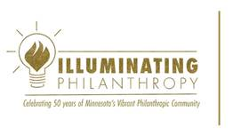 | KATINA MORTENSEN [She/Her/Hers]  Director of Public Policy  Minnesota Council on Foundations  612.335.3597  kmortensen@mcf.org  mcf.org

