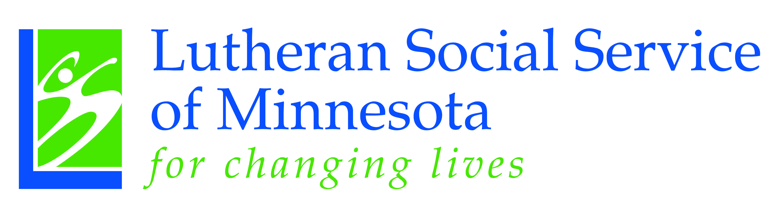

March 2016

Dear Legislative Member:

I am writing in support of HF 3009 on behalf of the LSS Caregiver Support and Respite Program and the family caregivers.
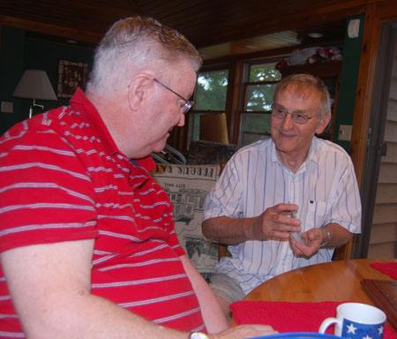
LSS Caregiver Support and Respite works to keep chronically ill people who are 60 years of age and older in their homes and out of institutional care for as long as possible. We assist family caregivers in remaining healthy and strong by decreasing caregiver burden and increasing caregiver competency so that they can continue in their crucial role as the backbone of long term care in the state—which includes over 500,000 unpaid Minnesotan caregivers. Every day, family caregivers demonstrate extraordinary love, dedication and courage in helping family and friends. According to the Department of Human Services, 92% of caregiving is done by a family member, and every 1% drop in this care would cost the public $30 million dollars annually.

The funding we receive falls substantially short of the needs and services for family caregivers and we are asking for your help to maintain this program and keep it a viable service. Each year there is a higher demand for caregiver services as our population is aging and there are more families who find themselves taking care of an elderly family member.
We truly hope you will strongly support this legislation as it strengthens this very essential and worthwhile service for the seniors in their communities. The health and well-being of our seniors depends on your support.

In closing I would like to share with you some words from a respite client that reflect the importance in the work that we do.

Caring for my husband who has Parkinson’s disease has been the biggest challenge of my life. Lutheran Social Service Caregiver Support and Respite Program saved my life. I got to the
point where I didn’t know how I could continue caring for my husband on my own because I was so tired and had no one who could help me. LSS provided me with a wonderful respite worker who has become like an extended part of my family. She not only makes life better for me but for my husband as well. He is so happy when she comes! I now have the support I need to continue
on my caregiving journey. LSS Client Testimonial
Thank you for the opportunity to share with you the story of caregivers statewide.
Respectfully Submitted,
Monica Douglas
Monica Douglas, Senior Director
1.800.488.4146 or 218.233.7521
715 North 11th St., Suite 401C, Moorhead, MN 56560

