March 30, 2016

Representative Brian Daniels
551 State Office Building
100 Rev. Dr. Martin Luther King Jr. Blvd.
Saint Paul, Minnesota 55155
Re: Letter of Support for HF 3438

Dear Representative Daniels,

Please accept this letter of support for HF 3438 which provides funding to develop educational materials to increase awareness of the careers available in senior care. HealthForce Minnesota, one of 8 Centers of Excellence within the Minnesota State Colleges and Universities system, is aware of the workforce challenges facing the senior care sector. A career awareness campaign specifically targeted to youth, dislocated workers, and Minnesota’s rural communities is important to increase the pool of potential employees for this critical, and growing, segment of the healthcare sector.
HealthForce Minnesota has a 10-year history of working with employers, healthcare associations, state agencies, and educators (including the University of Minnesota and private colleges), to identify and address healthcare workforce issues. One area of challenge is the lack of an intentional campaign to showcase the many career opportunities and pathways that exist in caring for seniors. While there is a gap in this area, the work HealthForce Minnesota has done through Scrubs Camps shows the impact career awareness initiatives can have. Students attending one of our 16 Scrubs Camps this summer will learn through hands-on activities and site visits about careers related to aging and older adults. At every camp, we see many “light bulb moments,” and believe a broader statewide approach will have similar results. Working with our stakeholders in Minnesota, we can turn the light bulbs into spotlights and continue developing a strong healthcare workforce pipeline to prepare for Minnesota’s future.

Sincerely,
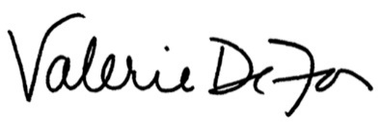

Valerie DeFor
Executive Director

