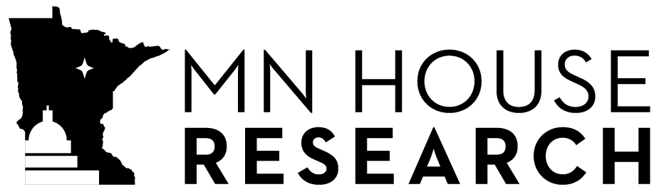
H.F. 1863
Delete-everything amendment (H1863DE2)
Subject Continuing appropriations; government shutdown
Authors Lillie and others
Analyst Colbey Sullivan (State Budget)
Matt Gehring (State Government)
Date February 6, 2020

Overview
This bill would appropriate money necessary to pay the salary and benefits of employees in the executive, legislative, and judicial branches in the event of a government shutdown at the start of a new biennium.

Summary
Section | Description
Employee salaries and benefits in event of state government shutdown.
Provides a statutory appropriation for state employee salary and benefits in the event of a state government shutdown, unless expressly superseded by a later-enacted law. A reimbursement payment for lost salary and benefits would be made upon the employee’s return to work. Employees in the executive, legislative, and judicial branches are included.
Subd. 1. Definition. Defines the term “government shutdown” for purposes of this bill.
Subd. 2. Payment required. Requires employees to be paid for lost salary and benefits resulting from a government shutdown. An employee is eligible for the payment only upon their return to work.
Subd. 3. Appropriation; limitation. Appropriates money necessary to make the payments to employees required by this bill. The appropriation is limited to the amount appropriated for general operations of the affected agency, office, or department in the prior fiscal year.
Subd. 4. Certification of amount for employees in the legislative and judicial branches. Requires legislative and judicial employers to certify to Minnesota Management and Budget (MMB) the amount needed to pay salary and benefits for their employees. Requires MMB to make the certified amount available on July 1 or on a schedule that permits the employer to pay its employees in a timely manner.
Subd. 5. Subsequent appropriations. Provides that any subsequent appropriation for regular operations may only supersede and replace the appropriations provided by this bill by express reference.

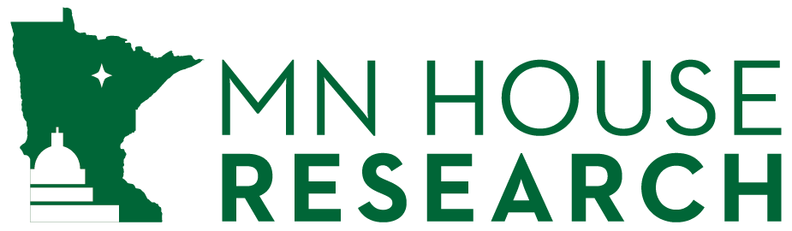
Minnesota House Research Department provides nonpartisan legislative, legal, and information services to the Minnesota House of Representatives. This document can be made available in alternative formats.
www.house.mn/hrd | 651-296-6753 | 600 State Office Building | St. Paul, MN 55155

