Journey Home USA works in Partnership with Veterans, volunteers, donors and communities to build homes and provide affordable homes to low and moderate-income Veterans and their families to ensure long-term affordability, accessibility and sustainability.
Journey Home USA offers the opportunity home-ownership based on what you can afford through a bank-backed home-loan and offsets the difference in cost through generous support of our donors.
Creating a stable home environment can significantly and positively impact the quality of life for Veterans and their families.
Our goal is to not just build a starter home but to build forever homes for our families.
Two Paths to stable housing with Journey Home USA
Rental: Our model allows us to build homes that can be rented by Veterans and their families until they are financially ready to secure a bank-backed mortgage to purchase the home based at 30% of their income. Rental Rates are set at no more than 30% of income levels.
Purchase: Homes are either new or completely renovated homes that meet long-term efficiency, affordability and accessibility needs for our Veterans. Homes are sold to Veterans and their families for no more than 30% of their income who have secured a bank-backed mortgage.

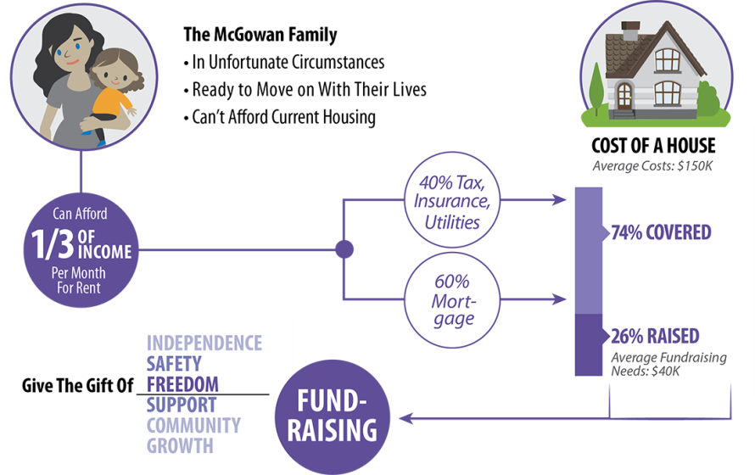

How we are able to sell a home below cost? Because we are a registered 501c3 non-profit we are mission driven and supported by donors who support our mission to provide affordable housing in safe neighborhoods served by great schools for families at risk, military veterans and their families.

Silent Second Mortgage Details
To ensure that our homes are honoring our donors commitment and families are being stabilized we hold a decreasing silent second mortgage on the home that makes up the difference between cost and purchase amount.
- Year’s 1-5 100% of Cost Difference held in silent second mortgage. With first right to buy back the home for original purchase price.
- Years 6-15 second mortgage decreases by 10% each year until no longer exists or home is paid off (which-ever is first.) Journey Home USA retains first right to buy back home at appraised value minus second mortgage remaining amount. This means that equity in the home is being built and belongs to the Home Owner.
- No payments are ever made on the silent second mortgage unless the home is sold on the competitive market then Journey Home USA is paid amount of second mortgage.
Qualification Requirements
- Must have lived in Minnesota for at least the past one-year
- Must acknowledge and agree to be a good partner with Journey Home USA
- Earn 40%-80% Area Median Income
- Ability to pay up to 30% Income
- Perfect credit is not required. Coaching to reach your financial goals and meet underwriting criteria for ownership can be arranged.
- Income sources can include: employment, pubic assistance of cash, social security, disability etc.
- Criminal Background checks will be completed and reviewed for compatibility.

