To: Minnesota House Judiciary Finance and Civil Law Committee Chair Jamie Becker-Finn and members
From: Minnesota Law Enforcement Coalition
Date: March 21, 2022

Re: Opposition to House File 3398: Time and Manner of Service: No Knock Warrants.

Dear Members of House of Representatives:

The Minnesota Chiefs of Police Association (MCPA), the Minnesota Sheriffs’ Association (MSA), and the Minnesota Police and Peace Officers Association (MPPOA) represent more than 300 police chiefs, 87 county sheriffs, and approximately 10,400 rank-and-file officers, respectively.

On behalf of Minnesota’s three largest statewide law enforcement associations, we are writing to respectively convey our opposition to House File 3398.

Mn. Stat. 624.14 sets forth the parameters and requirements for Time and Manner of Service: “No Knock Search Warrants.” The present statutory language provides law enforcement clear and balanced direction on how to apply for and execute a “No Knock Search Warrant.” As identified in the law, the intent of the present statutory language is to prevent the loss, destruction, or removal of the objects of the search or to protect the searchers or the public. The proposed amendments to the statute will significantly limit law enforcements ability to avail themselves in regards to the intent of the statute. The proposed language will limit the ability to protect those executing the lawful search warrant or the public while jeopardizing the preservation of potentially relevant investigative evidence.

Limiting the use of these warrants to confirmed “hostage” situations does not address the needs nor the perceived issues related to “No Knock Search Warrants.” Most confirmed “hostage” situations would most likely involve “exigent circumstances” and allow law enforcement to potentially enter a location without the need for a search warrant. This is already well-established law and is a general exception to the warrant requirement. In addition, the thirty-second requirement under the current language will affect all “knock and announce” warrants and could lead to significant danger to officers. Those violent criminals that are subject to the warrant, when a “no-knock warrant” would be justified, would now have ample time to arm themselves.

The proposed new training and oversight language can a play a role in supporting law enforcement moving forward and would be helpful. However, another mandated class that is broadly required to all sworn peace officers in our state (many rarely execute a “No Knock Warrant”), would be burdensome and cost-prohibitive to many of our members. Any additional training required must be funded appropriately so police departments can comply.

At this time, we cannot see how the present statutory language does not address all of the concerns raised by the legislature. Our Minnesota Law Enforcement Coalition strongly supports any continuing effort to protect citizens and support law enforcement but we cannot support House File 3398.

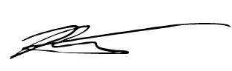
Sincerely,

Brian Peters
Executive Director, Minnesota Police and Peace Officers Association
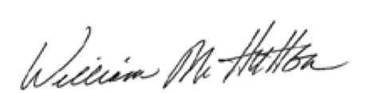

William M. Hutton
Executive Director, Minnesota Sheriffs’ Association

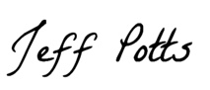

Jeff Potts
Executive Director, Minnesota Chiefs of Police Association

