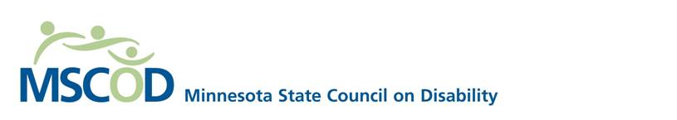

February 1, 2017

Representative Nick Zerwas

433 State Office Building

100 Rev. Dr. Martin Luther King Jr. Blvd.

Saint Paul, Minnesota 55155

Representative Zerwas:

The Minnesota State Council on Disability (MSCOD) would like to offer its support for HF 225.

As an agency charged with advising the State on the impact of policy on the lives of Minnesotans with disabilities, we strongly believe that raising the spenddown limit for Medical Assistance would offer a more sustainable path out of poverty for those individuals. Medical Assistance, as it is currently structured, lets Minnesotans with disabilities fall into a cycle of poverty, where they are forced to spend their income down below the poverty line to maintain eligibility.

Allowing people with disabilities to build up their assets will enable them to survive catastrophic life events and leave them better situated, financially, for living independently and enjoying the full promise of Olmstead Reform.

If you have any questions, please contact MSCOD’s Legislative Coordinator, George Shardlow, at 651-666-8628 or [George.shardlow@state.mn.us](mailto:George.shardlow@state.mn.us).

Sincerely,

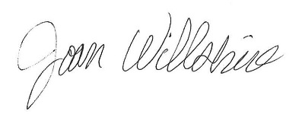

Joan Willshire, Executive Director

Minnesota State Council on Disability

