Project
Description/Location: The Roseau River Wildlife Management (RRWMA) is located in northwestern Minnesota along the Canadian Border. This wildlife impoundment was constructed in 1952 and 1953. The stated purpose of the project was wildlife enhancement and flood control. The RRWMA project was modified in the late 1980’s to extend its life and to increase its flood control benefits.

This impoundment has provided many years of flood control benefits to the area, but over the years of operations it has become evident that having the ability to transfer waters between the pools to aid in flood control is beneficial. Experience has also been shown that being able to discharge large volumes of water, from the impoundment, before the Roseau River flood reaches this area, would increases the flood damage reduction effectiveness of the available flood water storage, thereby lessening damages downstream on the Roseau River and the Two Rivers.

Roseau River Wildlife Management Area Pool 3 Outlet Project

Proposer
Roseau River Watershed District

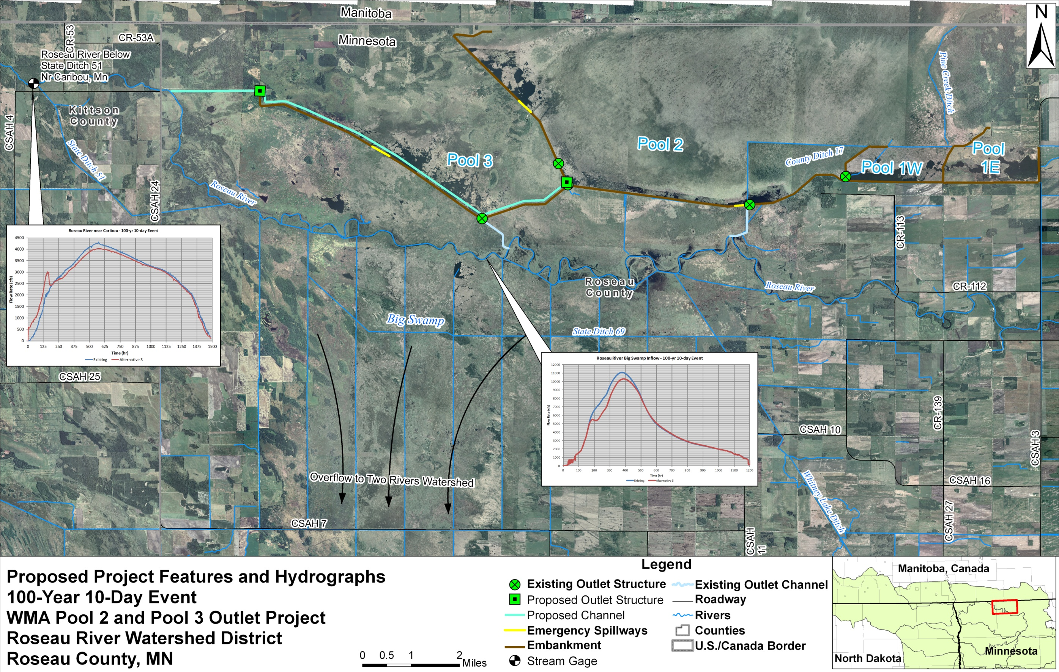

Project Benefits
Flood Control This is a multi-purpose project to:

- address the need to repair or replace the failing control structure between Pools 2 and 3;
- improve water level management on the WMA for vegetation management;
- control pool bounce on the WMA to improve nesting success;
- provide more efficient flood storage and improve the timing of 8,000 A-F of flood storage in the Roseau River Wildlife Management Area;
- provide flood damage reduction downstream at Caribou by decreasing peak flows at Caribou;
- manage storage and flow release in beneficial consideration of Red River peak flows;
- provide flood damage reduction in agricultural areas upstream and south of the Big Swamp along the Roseau River in Moose, Soler, Dieter, and Pohlitz Townships.

Habitat Restoration Stream flow augmentation, improved dissolved oxygen levels, enhanced fish habitat, and improved water level management.
Erosion Reduction Reduction in riverbank erosion and bank sloughing on the Roseau River.

Project Cost: $3,000,000 State75% ($2.25M) / Non-state 25% ($0.75M)

Status: Proposed, under design
 | Prior Years Funding | FY2015  (7/1/14-6/30/15) | FY2016  (7/1/15-6/30/16)
Funding | FDR $0.200M  RB/WD $0.100M | FDR $0.150M  RB/WD $0.500M | FDR $2.650M  RB/WD $0.150M
Engineering, Acquisition, Construction | Preliminary Engineering | Final Design, Permitting, PH 1 Construction | Construction  Completion
Key: PT=Project Team; WG=Flood Damage Reduction Work Group; RB=Red River Watershed Management Board; WD=Watershed District; FDR=Minnesota DNR; O=Other

Partners: Red River Watershed Management Board and State of Minnesota Flood Damage Reduction Program

