March 14, 2023

Chair Zack Stephenson and Members of the House Commerce Committee,

On Behalf of Minnesotans for Lawsuit Reform, we strongly urge you to consider the high risk of increased litigation and fraudulent claims if H.F. 2249 is enacted.
“Resident relative” exclusions contained in liability insurance policies are in place for a very good reason. While there are avenues for an injured party to seek relief if they are injured by another party, these avenues are correctly restricted if the injured person is closely related to the person that caused the injury.
H.F. 2249 would encourage family members to sue each other even over minor injuries and could incent these family members to collude to inflate the severity of the injury.
Minnesota’s courts have long upheld resident relative exclusions for this very reason.
There are often first party coverage benefits such as health insurance that cover policyholders who are injured. Utilizing such coverage helps prevent unwarranted litigation.
H.F. 2249 would unnecessarily increase the number of lawsuits filed putting stress on the state’s court system and causing insurance premiums to rise.
The bill is not necessary, and we strongly urge members to vote no.

Respectfully,
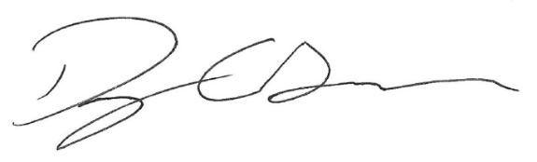
Doug Grawe, CEO, The Grawe Group
Board Chair, Minnesota for Lawsuit Reform

