12 May 2022

Honorable Members of the Jobs, Energy & Commerce Conference Committee
Chair Noor; Representatives Ecklund, Long, Stephenson, Swedzinski
Chair Pratt; Senators Rarick, Dahms, Senjem, Frentz

Re: BAM Written Testimony; SF4091

On behalf of the Builders Association of Minnesota (BAM), I would like to thank you for the opportunity to share written testimony. Our membership of 1600 residential builders, remodelers, subcontractors, and industry partners are joined together through eleven local associations across Minnesota, and we are proud to be the statewide voice of the Minnesota Home Building Industry.

Thank you for your public service, and the work you do to address Minnesota’s housing affordability, availability, and home ownership crises. Following are issues we would like to highlight for your consideration:

BAM Supports:

▪️House and Senate provisions that 1) reduce building permitting fees (House: includes a sunset; Senate: is permanent); and 2) address window cleaning safety features in new buildings (Senate language preferred).

BAM Opposes:

▪️House provisions that mandate Paid Family & Medical Leave, Earned Sick & Safe Time, and OSHA penalty increases, especially at a time when businesses large and small are facing massive headwinds in workforce shortages, supply chain bottlenecks, and rising inflation.

▪️BAM is also concerned about the cumbersome and costly House provision imposing an energy benchmarking mandate for buildings.

Sincerely,
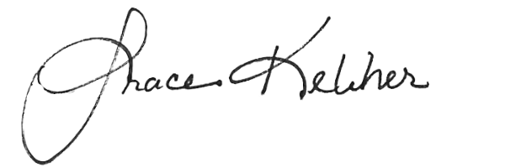

Grace Keliher, Executive Vice President
Builders Association of Minnesota
161 St. Anthony Avenue, Suite 817 Saint Paul, MN 55103
grace@bamn.org / 612-501-3071

cc: Nick Stumo-Langer, House Committee Administrator (nick.stumo-langer@house.mn)
Trisha Elite, Senate Committee Administrator (tricia.elite@senate.mn)

