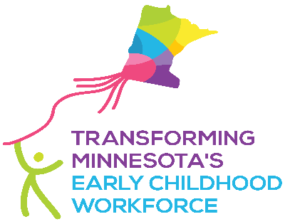

May 10, 2022,

Dear Members of the Health and Human Services Conference Committee,

The early childhood workforce is an essential workforce. These early educators are key players in children's healthy brain development and help build the foundation that children need for future learning, behavior, and health. Early educators are also key supporters of working parents, businesses, and our economy. Without a strong and healthy early childhood workforce, we cannot sustain a strong and healthy economy.

On behalf of Transforming Minnesota’s Early Childhood Workforce--a public-private initiative formed in 2016 to research, analyze, consider, and recommend policy issues related to the early childhood workforce, we urge you to include the following elements in the final omnibus bill:

- Completion of a new Early Childhood Education Workforce Study. The would be an update of a study last completed in 2012 and would provide a consolidated report of current data including wages, income, and benefits in the industry; and barriers to entering these careers or retaining workers in the field.

Having a comprehensive report of the early childhood education workforce in Minnesota would allow legislators, employers, and communities to address its needs more accurately. Understanding changes within the early care and education workforce is critical to our state’s growth.

- Continued funding for the Child Care Workforce Development Grants. This funding enables economically challenged individuals to obtain the skills training, career counseling, and job placement assistance necessary to begin a career in child care.

The COVID-19 pandemic has threatened the already underfunded child care industry. Recruitment and retention of qualified educators is even more challenging. Providing support and incentives to encourage Minnesotans to join the early childhood workforce is a necessary element to our efforts to stabilize and grow this system.

Thank you for your consideration of these recommendations, and for the work you do to support the “workforce behind the workforce” through these efforts.

Sincerely,

The Transforming Minnesota’s Early Childhood Workforce Team

