**The MN Family Resiliency Partnership**

**Formerly Known as the MN Displaced Homemaker Program**

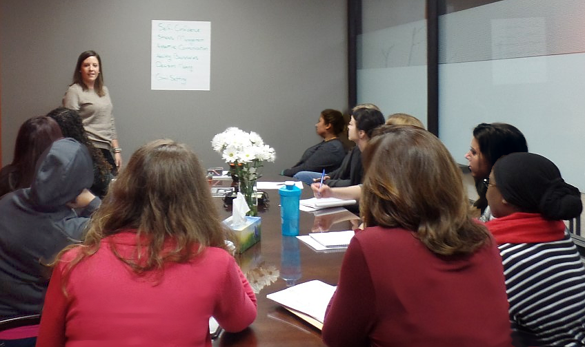

***OUR MISSION:***

To increase the self-sufficiency of participants and their families.

***OUR PARTICIPANTS:***

Participants are people who have been at home caring for family while dependent on someone else’s income. They have lost that source of income through a personal loss--death, disability, divorce, abandonment, or loss of public assistance. Amid this transitional crisis they face a radical life and occupational reorientation.

***OUR PROGRAM:***

The Minnesota Family Resiliency Partnership is a pre-employment and family stabilization program. It is the ONLY program in the state designed to help this unemployed or under-employed population to address their unique barriers to self-sufficiency.

The program addresses work readiness by teaching participants:

* essential life-skills needed to stabilize their family situation.
* necessary job-related skills needed to conduct a successful job search.
* intensive individualized support.
* homelessness intervention and prevention.
* training and college academic advising for career development.
* assistance with gaining employment.

***OUR COVID 19 ADAPTATION:***

* Virtual workshops.
* Chrome laptop lending library.
* WiFi Hot Spots.
* PPE for participants and their children.
* Meeting outdoors if possible.
* All services remained available to all

participants.

*Self Confidence*

*Assertive Communication*

*Boundaries*

*Stress Management*

*Goal Setting*

*“I don’t know how my family would have survived if it wasn’t for this program.” C.A.*

*“Six months after my husband passed away from cancer, I lost my job of 18 years. At the age of 54, this program addressed everything I needed to do to survive and re-enter the workforce.” J.M.*

*“They helped me develop a higher paying career rather than just getting a job.” V.R*

***BARRIERS TO SELF-SUFFICIENCY AND EMPLOYMENT:***

Participants in the MN Family Resiliency Partnership are:

* Female—97%.
* Brown, black, and indigenous—32%.
* Victims of domestic violence—60%.
* Not receiving court ordered child support—75%
* Homeless—22%.

***OUR OUTCOMES:***

* Served 4,318 low-income participants and their families, including their children.
* 97% successfully completed their program.
* 6% enrolled in college.
* 32% became employed with an average hourly wage of $13.14 per hour.

***OUR FUNDING:***

* The Minnesota Family Resiliency Partnership has been funded primarily by fees with little or no tax dollars since 2003.
* It is a Career Pathways program administered by the Minnesota Department of Employment and Economic Development (DEED).
* All participants enrolled in the Minnesota Family Resiliency Partnership live at 200% of the federal poverty guidelines or even less.

***FINANCIAL OUTCOMES:***

* Participants who became employed in SFY 19 and 20 contributed $11,200,949 in local sales, sales taxes, and income taxes to the state economy annually.
* Each low-income participant diverted from MFIP saves the state $19,181 annually per family consisting of one adult and two children. This results in $23,382,406 in savings to the State of MN in SFY 19 and SFY 20 annually.
* The regional MN Family Resiliency Partnership is funded primarily by fees. The cost per participant for 12-months of service is $1,498. Other DEED programs are funded at $3,500 - $5000 per participant.

***Minnesota Family Resiliency Partnership service areas and***

***contact information:***

We are requesting $100,000 to be divided between 6 partner programs.

***The state realizes a $26.89 to $1 return on its investment***

***in the Minnesota Family Resiliency Partnership.***

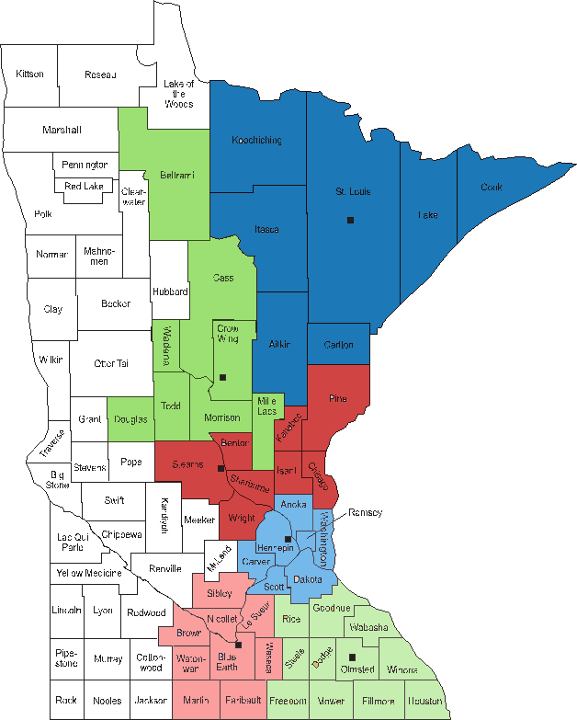

**CHOICES of Southeast Minnesota**

Rochester Community & Technical College

851 – 30th Avenue Southeast

Rochester, MN 55904

507-280-5517

**Life-Work Planning Center**

127 South Second Street

Suite 210

Mankato, MN 56001

507-345-1577

**AVIVO**

2438 27th Avenue S.

Minneapolis, MN 55404

612-752-8100

**Rebuilding Lives—**

**Tri-County Action Program**

1210 – 23rd Avenue South

PO Box 683

Waite Park, MN 56387

320-251-1612

**META 5**

Central Lakes College

501 West College Drive

Brainerd, MN 56401

218-855-8010

**Lives in Transition – AEOA**

702 – 3rd Avenue South

Virginia, MN 55792

218-327-6748

**Lives in Transition – AEOA**

Virginia, MN 55792

218-327-6748

**META 5**

Brainerd, MN 56401

218-855-8010

**AVIVO**

Minneapolis, MN 55404

612-752-8100

**Life-Work Planning Center**

Mankato, MN 56001

507-345-1577

**Tri-County Action Program – Rebuilding Lives**

Waite Park, MN 56387

320-251-1612

**CHOICES of Southeast Minnesota**

Rochester, MN 55904

507-280-5517