Legislative Testimony for Bill HF289

My name is Jaclyn Doyle and I have been the Executive Director of the LifeCare Pregnancy Center of Thief River Falls since 2017.
I am providing a written testimony regarding House Bill HF289 which funds the PA Grant Program that supports pregnant people carrying their pregnancies to term and new parents caring for babies after birth. I want you to know that I and our organization fully advocate for continued funding of this Bill.
This Bill is important because in rural Northwest Minnesota, our Center is one of the only locations available within six counties to provide pregnant persons with evidence-based education to care for themselves and their unborn child/newborn infant during and after pregnancy. Our clients are also assisted with connections to healthy prenatal care, nutrition programs such as WIC, Inter-County Health programs, and other Social Services to ensure they have the support they need. Finally, this Bill helps our Center provide much needed material assistance to those who can not afford the expense of infant care and safety, such as cribs, car seats, diapering and formula.
Without Bill HF289 funding, our Center of 25 years would likely no longer be able to provide such services to our communities. Reliance on private donor funding only, in our rural location, is not enough to continue aiding our average of 40+ clients annually.
Thank you for hearing out my testimony.

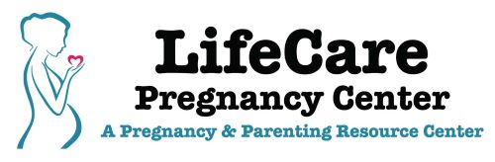
Jaclyn Doyle, Executive Director

204 LaBree Ave N, Thief River Falls MN 56701
218-681-1279

