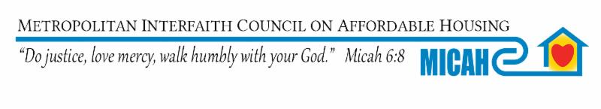
Dear Chair Jennifer Schultz and Members of the Human Services Finance & Policy Committee
MICAH Supports HF 3568 (Her) - Housing support countable income modified.

HF 3568 People experiencing homelessness have expressed to MICAH paying 90% of their income is a barrier to utilizing the Housing Support Program.

By paying only 30% of their income people experiencing homelessness will be able to take care of other personal needs and save money so they may move into more independent housing in the future.

MICAH supports this bill and would encourage you to expand this to include all sources of income.

MICAH’s mission is to ensure everyone, without exception, has a safe, decent accessible home that is affordable for them.
Over half of MICAH’s Board and staff have experienced homelessness, housing instability or discrimination and over 70% of our Board and staff are from diverse communities.
MICAH’s members are actively involved in our community to address the immediate needs of people at risk of and/or experiencing homelessness and creating and maintaining affordable housing opportunities. Our primary goals are to prevent homeless and to have homes that are affordable for everyone.
Over 550,000 Minnesota Households are paying over 30% of their income for housing. Which means they are making choices between paying rent, buying food, clothing, paying unexpected bill, etc. and are constantly at risk of homelessness with the loss of income, an accident, health crisis, or emergency .

God’s peace,
Sue Watlov Phillips, M.A.
Executive Director MICAH and President, National Coalition For The Homeless

MICAH 463 Maria Ave. St. Paul, MN 55106 651-646-0612 www.micah.org

