Housing First
At Neighborhood House we understand the importance of stable housing for families. Our Housing Stability program prevents evictions and homelessness through emergency financial assistance and working collaboratively with county and community partners to locate available resources. We follow a “housing first” model of care because we believe that safe housing is the foundation needed to address any other concerns in a person’s life. In crisis situations, our staff intervene to restore families to equilibrium and to prevent future crises by providing a continuum of services.
Eviction Prevention
Our participation, presence, and collaboration with Ramsey County Housing Court sets us apart from nearly every other social service agency assisting with housing. It is here where we meet many families who are facing the devasting reality of eviction – an action that will follow them for years and limit their ability to secure safe and stable housing in the future. When families connect with us in Housing Court, we are able to quickly access resources prior to facing the judge and help them resolve their issue, which is often less than $3,500, and thereby avoid eviction and homelessness. This is especially important for families with school-aged children and seniors.
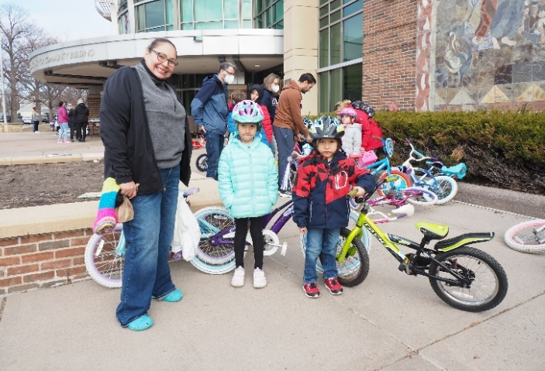
Request
Housing has become a critical issue across the country leaving cities to figure out how to handle the epidemic of unhoused individuals. Neighborhood House is prepared and eager to be part of the answer. Neighborhood House is requesting $2.4 million over two years for rental assistance for families facing eviction, delinquent utility fees, and administrative costs. These funds will enable Neighborhood House to assist an additional 550 families remain in safe, secure housing.
Contact
Bill Numbers
HF 1579 (Pérez-Vega)
SF 1310 (Pappas)
Nancy Brady, President & CEO
nbrady@neighborhoodhousemn.org
651.789.2575
Patty Paulson, Housing Stability Manager
ppaulson@neighborhoodhousemn.org
651.789.3689

www.neighborhoodhousemn.org

