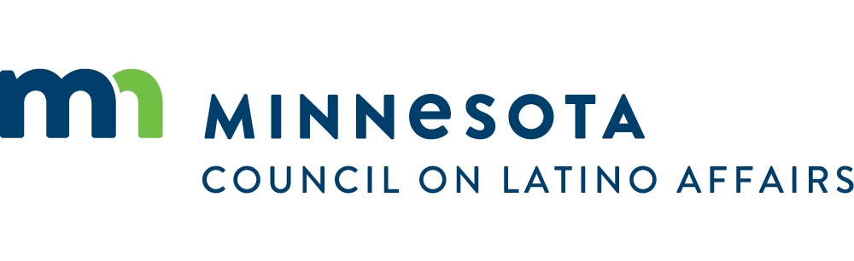
February 5, 2023
Dear Madame Chair Liebling and members of the Health Finance and Policy Committee:
On behalf of the Minnesota Council on Latino Affairs I write in support of H.F.639 (Bahner), to fully fund the Community Solutions for Healthy Child Development grant program and make it permanent.
Children of color and American Indian children face a steeper ladder of success in Minnesota, and by 2035, these populations will make up one-quarter of the state’s residents. To address these disparities, the Community Solutions for Healthy Child Development grant program will support the strengths of communities of color and American Indian communities to develop strategies that promote early childhood and family healthy development.
As it has been successfully proven in the recent past with the first pilot grants, this program would continue to allow cultural communities across the state the flexibility to advance locally generated approaches to improve measures of well-being, based on a broad subset of child well-being outcomes from prenatal to 3rd grade. Organizations like Centro Tyrone Guzmán, CLUES, and La Red in the Latino community have been able to serve more families and children thanks to these grants.
H.F. 639 additionally addresses geographic equity, by prioritizing grant funding to areas of the state with high proportions of communities of color and American Indian communities. As a Council, we have conducted listening sessions across the state and, when it comes to early childhood education, we have heard first-hand the unique differences and needs in Greater Minnesota and the Metro area. We’ve seen first-hand that our respective communities are best positioned to analyze their unique strengths and this bill gives them the ability to leverage community expertise and work towards eliminating early childhood health disparities.
We appreciate your consideration and ask for your support for the sustainability of this program.
Sincerely,

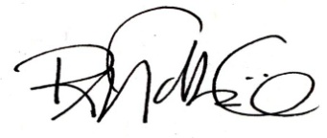
Rosa Tock, Executive Director

Centennial Office Building | 658 Cedar Street, Suite G-56, St. Paul, MN 55155| 651-757-1762
Website: MN.GOV/MCLA | Facebook: /MINNCLA | Twitter: @MINNCLA
An Equal Opportunity Employer

