February 15, 2023

Chair Zack Stephenson
House Commerce Finance and Policy Committee
449 State Office Building
100 Rev. Dr. Martin Luther King Jr. Blvd.
St. Paul, MN 55155

Dear Chair Stephenson and committee members:

On behalf of Minnesota Famers Union (MFU), I write to share MFU’s strong support for Representative Fischer’s HF1337, which will provide fair access to the parts, tools, and diagnostic equipment farmers and independent technicians need to repair modern day farm equipment. This legislation will ensure a competitive market for repair and restore farmers’ right to fix the things they own.

MFU is a grassroots organization that has represented Minnesota’s family farmers, ranchers, and rural communities since 1918. At our annual convention last year members voted to make limiting corporate control and ensuring competitive markets a top priority for 2023. This includes passing Right to Repair legislation like HF1337, which is critical to a genuinely competitive market for repair services.

Modern day tractors and combines rely heavily on software to operate. For example, a single combine harvester can include as many as 125 software-connected sensors. A problem with any one of these sensors, even a simple diagnostic error code, will send the machines into “limp mode” and make them useless. To get the tools, manuals, and diagnostic equipment necessary to make needed repairs, farmers have to go through manufacturers and authorized dealers. They are unable to make these kinds of repairs themselves or utilize independent repair shops in their community.

This effective monopoly on repair is on top of extreme concentration in equipment manufacturing. Just three companies manufacture 95% of large tractors in North America and control the entire combine market. While the list price for a new tractor can range anywhere between $123,000 and $590,000, repair is where manufacturers make their money. Estimates have found that the profit margins for repairs can be five times higher than the profits from selling equipment.

Without the right to repair, simple fixes like clearing diagnostic error codes can cost farmers thousands of dollars and result in delays during planting and harvest, costing farmers even more. When relying on a short window for a year’s worth of income, lengthy delays can become devastating to a farmer’s finances.

Manufacturers’ control of repair also limits the work of independent repair technicians, which further exacerbates the decline of independent repair shops. Even among dealerships, larger chains have started to roll up mom and pop shops, further eroding the choices farmers have. A 2021 survey by the Public Interest Resource Group found that 65% of farmers have access to fewer equipment dealerships than they did just five years ago. All of this puts more and more power and control in the hands of the big three manufacturers.

MFU members care about this issue not only because it will have the practical effect of helping them get more timely repairs on their equipment, but also as a matter of principle. They strongly believe that—as an owner of equipment—they have a right to make repairs. In fact, many farms depend on making in-house repairs to better control costs.

It is also important to note that farmers increasingly rely on other digital technology, including cell phones, laptops, and GPS devices to monitor weather conditions, bid on livestock, and manage their risk in a global market for commodities. Many would benefit from the ability to repair this equipment as well.

Finally, we believe strongly that HF1337 will create a fair and open market for repairs that can support a healthy network of dealerships and repair shops. Many of our members receive excellent service from their local dealership and believe there is room for more independent technicians and independent farmers to engage in repair. We also believe that dealerships have the right to earn a fair margin on parts which is newly addressed in Sub. 2(f) in Rep. Fischer’s bill.

Thank you for your consideration and to Rep. Fischer for his strong leadership on this issue. If you have any questions, please contact our Government Relations Director, Stu Lourey, at stu@mfu.org or (320) 232-2047 (C).
Sincerely,
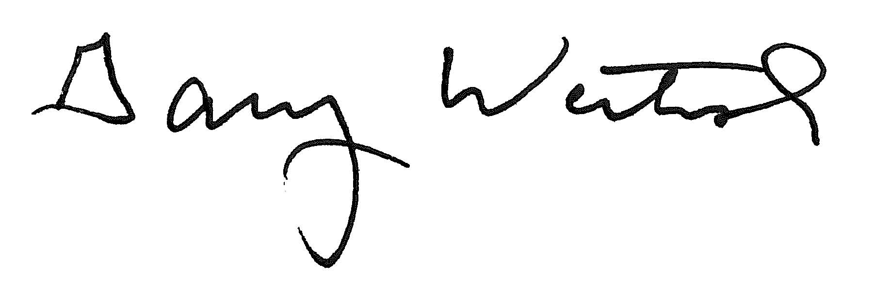
Gary Wertish
President, Minnesota Farmers Union

https://pirg.org/resources/deere-in-the-headlights-3/
https://www.farm-equipment.com/ext/resources/images/issues/2018/FE-September-2018/MarketShare.jpg
https://farmdocdaily.illinois.edu/2021/10/machinery-cost-estimates-for-2021.html
https://www.openmarketsinstitute.org/s/Report_RightToRepair_HanleyKellowayVaheesan-1.pdf
https://www.reuters.com/markets/us/fewer-us-tractor-dealerships-raise-costs-farmers-sector-consolidates-2022-09-01/
https://pirg.org/resources/deere-in-the-headlights-ii-2/

