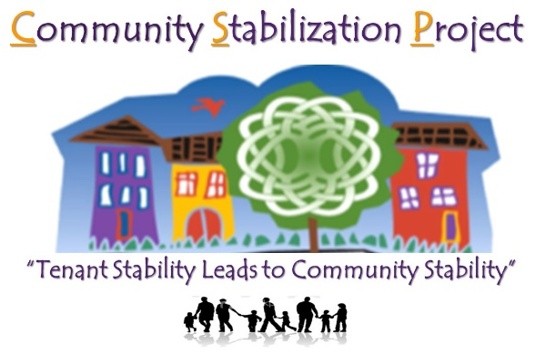
501 N. DALE ST., SUITE 203, SAINT PAUL, MN 55103
PHONE: (651) 225-8778
FAX: (651) 225-4160
E-MAIL: csp501dale@gmail.com
WEBSITE: http://csp501dale.wix.com/communitystabproject

Each Phone Call is an Opportunity
Community Stabilization Project (CSP) informs, educates, organizes, and advocates for social and economically disadvantaged tenants, preventing evictions and ensuring their rights are enforced. Through training, outreach, and a tenant hotline, CSP ensures that tenants and landlords alike are taking action to prevent displacement and to preserve stable, livable, healthy, and affordable housing across Frogtown and Rondo and beyond.

Without CSP, no organization would be there to stand up for—and with—most of these distressed tenants. CSP’s grassroots connections and strong base of local volunteers ensures it can be the first point of contact for tenants in need and can intervene to improve their stability and, in doing so, the stability of their communities.

A Range of Services
CSP provides the following services, support, and advocacy on a regular basis:
- Tenant-landlord training on housing search, retention, rights, and responsibilities
- Individualized counseling and hotline services to tenants facing distressed situations
- Specific education on issues like tenant screenings and unlawful detainers
- Assistance tenants in negotiations and court proceedings
- Referrals for tenants/Landlords in units facing Revocation of CO or other unstable housing circumstances
- Operation of an Emergency Rental Assistance Program for tenants facing eviction
- Support to tenants in acting on their rights to use the Tenant Remedies Act (TRA)
- Advocacy for the enforcement and improvement of laws such as the Cold Weather Rule & DSI
- Connection of tenants to other resources they need, from job training to mental health services

A Model for Empowerment
INTAKE/ADVOCACY  CSP reaches tenants, Landlords & homeowners through walk-ins, phone calls, referrals, and direct outreach, and then immediately works to establish a stable community housing relationship. | EDUCATION  CSP offers a rotating six-week tenant/landlord training, providing each with a full understanding  of tenant rights and their respective responsibilities. | ORGANIZING  After forming a relationship with tenants/landlords, CSP works with them and its community partners to address identified needs and pursue new policies and programs. | POLICY  CSP works with its communities and its legislators to advocate for housing policies that remove barriers and improve opportunities.

