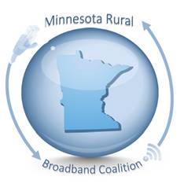
To: House Industrial Education and Economic Development Committee
Chair, Rep. Gene Pelowski, Jr.
491 Rev. Dr. Martin Luther King Jr. Blvd.
Saint Paul, MN 55155

From: The Minnesota Rural Broadband Coalition
2401 Broadway Ave #1
Slayton, MN 56172

March 30, 2022

Dear Chair Pelowski and Committee Members,

On behalf of our member organizations, the Minnesota Rural Broadband Coalition writes in support of HF14/4375. This bill would appropriate an additional $100 million to the Border-to-Border Broadband Grant Program from the state’s general fund. This funding would bring more long-term stability to a grant program that has only been funded on a one or two-year basis, yet continues to do great work bringing broadband service to rural Minnesota.

HF 14/4375 also includes provisions that would allow the state to match up to 75% of project costs for projects that are in some of the hardest to reach, low-density areas of the state. These areas are also typically the most expensive places to build a modern broadband network and would almost certainly not see private investment without the state’s assistance. Additionally, this legislation raises the project cap from $5 million to $10 million. This would allow larger projects—multiple townships or even whole counties—to receive funding through the grant program. The Coalition supports these items.

The pandemic has taught us that Minnesotans need broadband connections in their homes. 170,000 Minnesota households are not connected to 25mbps/3mbps connections (2022 state goal), and 240,000 households are not connected at 100mbps/20mbps (2026 state goal), mostly in rural areas.

The legislation before you today would ensure that the Border-to-Border Grant Program continues to partner with trusted internet service providers to bring needed investment in our rural Minnesota communities.

Thank you for dedicating your time and resources to hearing this bill and emphasizing the importance of broadband in Minnesota.

Respectfully yours,

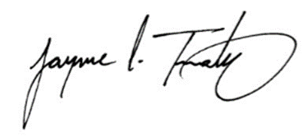

Jay Trusty
Chair
Minnesota Rural Broadband Coalition

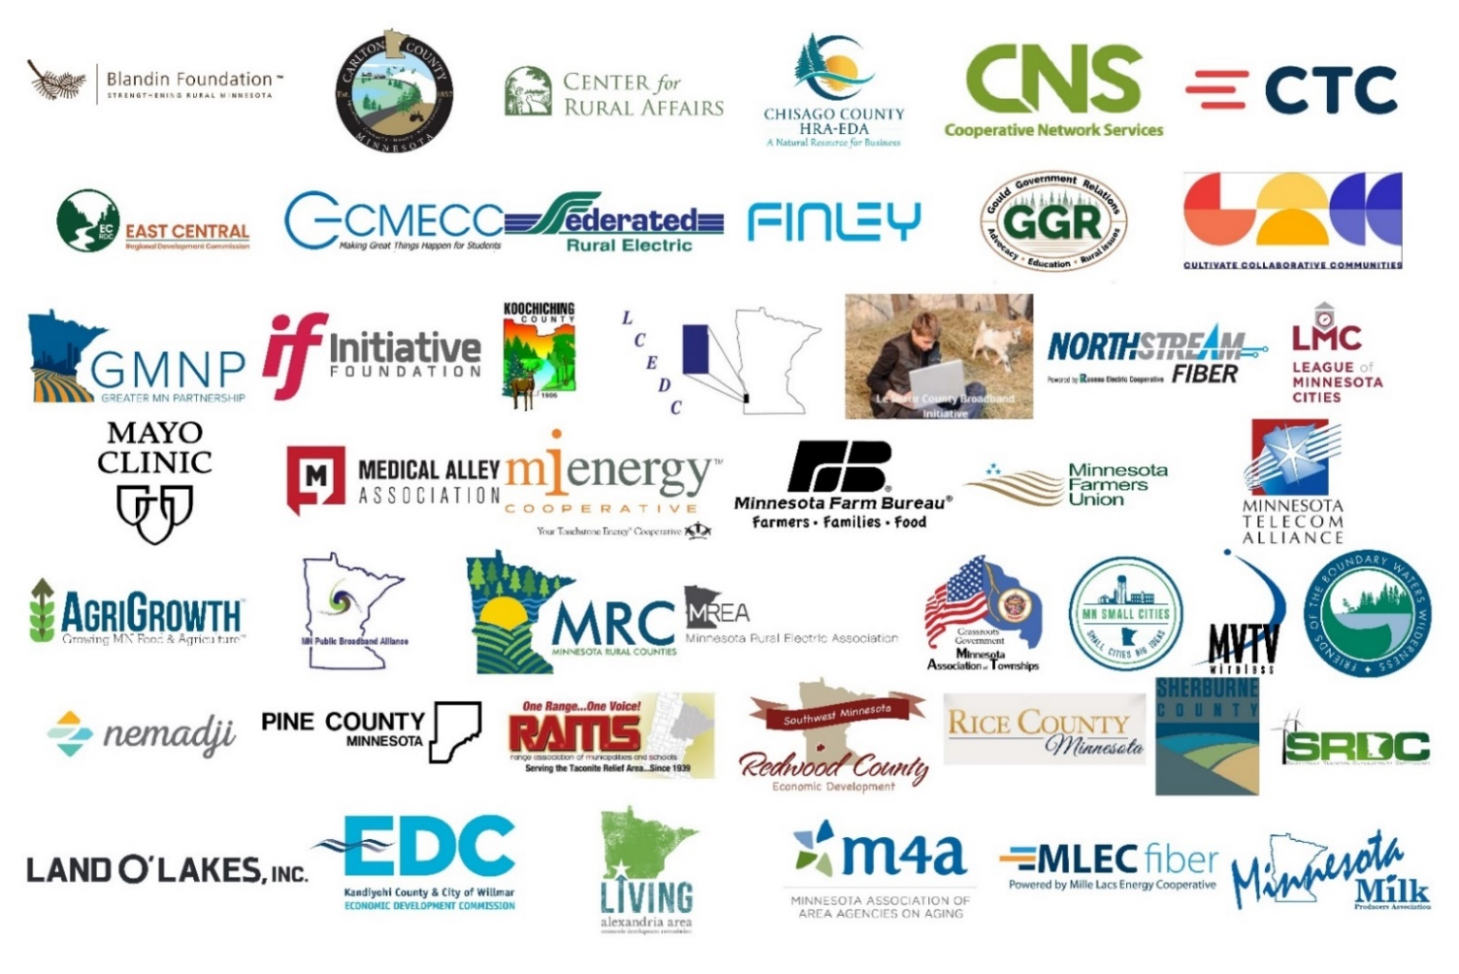
Minnesota Rural Broadband Coalition Members

