January 31, 2023

Representative Mike Freiberg
Chair, House Elections Policy and Finance Committee
381 State Office Building
St. Paul, MN 55155

Re: Support for HF 204 (Bahner)/SF 285 (Mitchell) – Electronic Signatures on Electronic Polling Books

Chair Freiberg,
On behalf of the Hennepin County Board of Commissioners, I am writing to express support for HF 204, a bill allowing the use of electronic signatures on electronic pollbooks. Electronic roster signatures represent a relatively small change in process for voters but will streamline the voting process for voters and voting administrators alike, leading to significant administrative benefits.
Electronic polling books have been used in Minnesota and many other states across the country for years, and they have improved the efficiency and accuracy of the voting process in polling places. There are currently 59 Minnesota counties already using electronic poll books. However, we are not taking full advantage of the benefits this technology can provide. Of the 36 states that our electronic poll book vendor operates in, we are one of only 4 states that do not allow or require electronic signatures for their rosters.
Allowing for electronic signatures minimizes election judge mistakes by walking the election judge through the check in and registration process and ensuring that signatures are captured properly. Electronic signatures also provide a backup in case the signed paper certificates and applications become lost or destroyed. There are also accessibility advantages for people with visual impairments or who have difficulty grasping a pen. The signature block area on an electronic pollbook is significantly larger than on a printed pollbook, and a voter can use their finger to sign if they are not able to hold a pen.
There are no additional costs to counties for making this change. The ability to collect and retain electronic signatures is already available through our vendor. The language of the bill is permissive, so that if a city or county does not employ electronic pollbooks or decides they would rather use wet signatures, they are free to do so.
I urge all members to vote for this bill.
Thank you for your leadership,

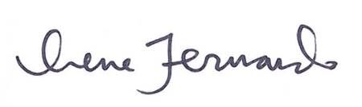
Irene Fernando, Chair
Hennepin County Board of Commissioners
300 South Sixth Street, Minneapolis, MN 55487-0040
hennepinD2.com | hennepin.us

