May 1, 2023

Dear Senate Conference Committee members:

As a member of the Mental Health Legislative Network (MHLN), we urge you to support much needed investment in Minnesota’s mental health care system by supporting the MHLN’s priorities. Specifically, we ask that you consider adopting the House language to fund a statewide program locator to help Minnesotans navigate the system, streamline voluntary engagement, reduce wait times, and improve access for all. As psychiatrists we see first hand the harmful consequences of our patients' inability to get timely access to services at all levels of care. Please vote to fund this essential asset in your upcoming conference committee!

If you have any questions please contact Linda Vukelich, Executive Director, Minnesota Psychiatric Society (l.vukelich@comcast.net) or Bill Amberg, Government Relations Counsel, Minnesota Psychiatric Society (Bill@amberglawoffice.com).

Sincerely yours,

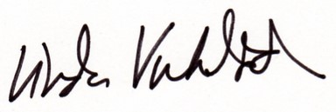
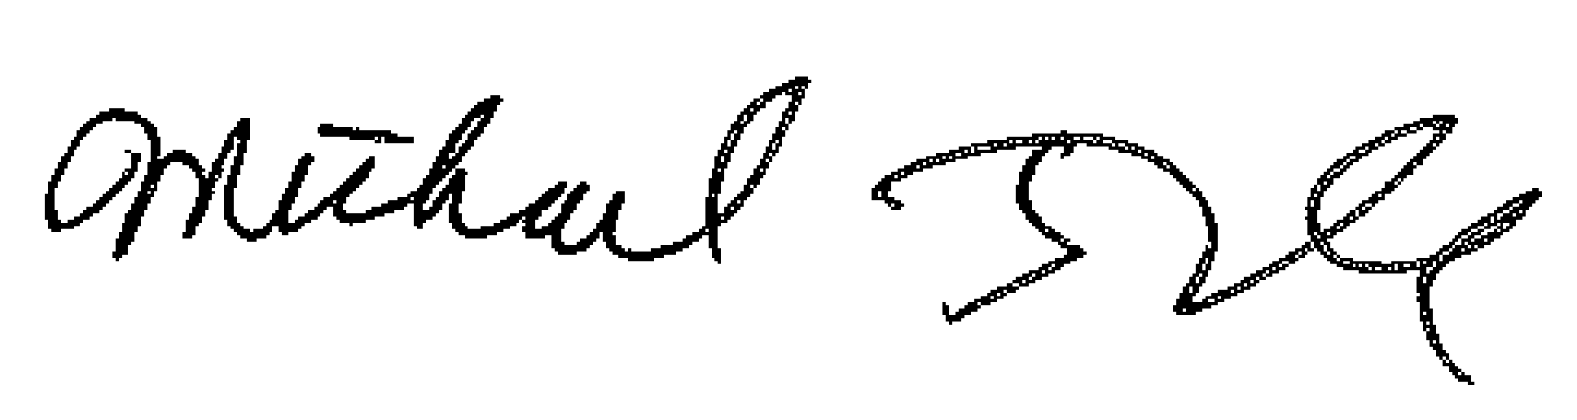
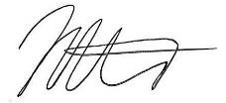

Matt Kruse, MD, FAPA Michael Trangle, MD, DLFAPA Linda Vukelich
MPS President MPS Legislative Committee Chair Executive Director

