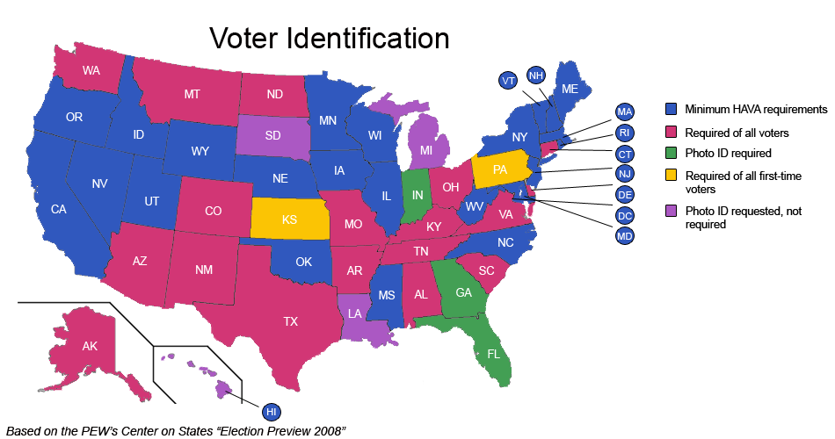

Photo ID Required for All Voters - require photo ID for all voters, however a provisional ballot is not granted if a voter does not bring a photo ID to the polls in these states

Photo ID Required for All Voters with Provisional Ballot Clause - require all voters to show photo ID for voting, however if a voter does not present photo ID at the polls a provisional ballot is granted

Photo ID Required for All Voters with Full Ballot Clause - require photo ID for voting, however if a voter does not present photo ID at the polls a Full ballot is granted

States that enforce only the HAVA Minimum - only enforce the minimum standard by the Help America Vote Act (HAVA) in which only require a photo ID when ID was not presented at registration

