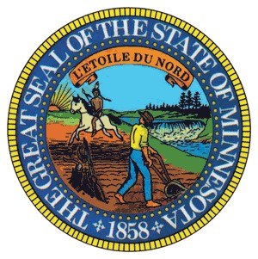
Minnesota House of Representatives
Aisha Gomez
State Representative
District 62A

Chair: Taxes Committee
Date: March 29, 2024
To: Rep. Dave Lislegard, Chair, Property Tax Division
From: Rep. Aisha Gomez, Chair, Taxes Committee
RE: Bill Referrals

As of Friday, March 29, 2024, the following bills are hereby referred to the Property Tax Division:

HF5164 (Vang) Brooklyn Center; special tax increment financing authority provided.
HF4340 (Niska) Ramsey; special tax increment financing authority modified.
HF3864 (Lislegard) Town aid calculation modified, and annual town aid amount increased.

CC: All Chief Authors
All Chief Author’s LAs
Rep. Greg Davids, Taxes Committee GOP Lead
Rep. Duane Quam, Property Tax Division GOP Lead
Carl Hamre, House Index
Ryan Inman, Revisor of Statutes
Sam Moyer, GOP Research
Sean Hadorn, DFL Research
Sean Williams, House Research
Alex Haigler, House Research
Jared Swanson, House Research
Justin Cope, House Research
Katrina Heimark, House Fiscal
Cynthia Templin, House Fiscal
Sean Rahn, Executive Director Majority Caucus
Chris McCall, Legislative Director to the Speaker

