
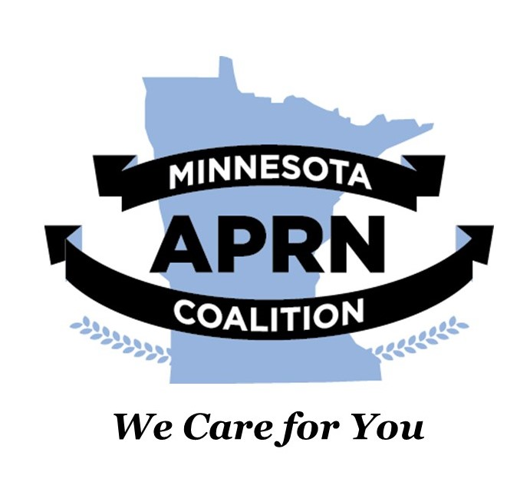
March 1, 2022
The Minnesota Advanced Practice Registered Nurses (APRN) Coalition and the Minnesota Nurse Practitioners (MNNP) organization heartily endorse HF 3696: Health data collection and use provisions modified, on the modification of health data collection and use provisions, and endorse a study and report on the systems used to pay health care providers.
Advanced practice nurses are committed to improving population health by:
- Rethinking healthcare infrastructure
- Expanding payments for primary care services
- Strengthening the primary care workforce

Nurse practitioners (NP) account for a large percentage of the workforce that delivers primary care. According to the American Association of Nurse Practitioners (AANP), 88.9% of NPs are certified in an area of primary care, and 70.2% of all NPs deliver primary care. The vast majority of NPs (69.7%) provide care to patients across the lifespan (AANP, 2021). According to the Minnesota Board of Nursing (2022), there are 10,746 licensed advanced practice nurses in the state. Of these, 71% (~7,682) are NPs and roughly 48% work in ambulatory settings. Certified Nurse Midwives also provide women’s primary healthcare with the American College of Nurse Midwives reporting that over 52% of midwives report primary care provision in their current practice (ACNM, 2012).
Providing whole-person care is a key tenet of primary care. This has long been a core value of professional nursing and advanced practice registered nursing. Our emphasis on health promotion and wellbeing and the provision of patient-centered care is reflected in our commitment to primary care. We, therefore, support HF 3693 and ask the legislature to support it as well.
Sincerely,
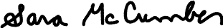
Sara McCumber, DNP, APRN, CNP, CNS Brian K. Goodroad, DNP, APRN, CNP, FAANP
President President
Minnesota Nurse Practitioners Minnesota APRN Coalition

