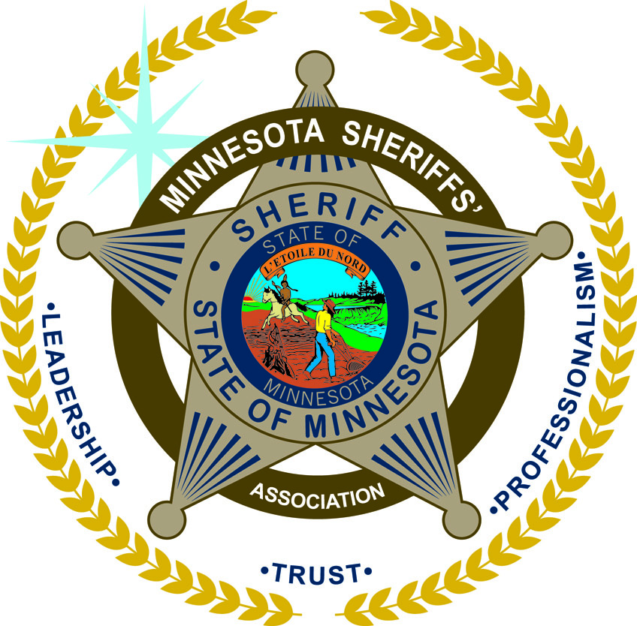
MINNESOTA SHERIFFS’ ASSOCIATION
___________________________________________________________________________________________________________________________________________

100 Empire Drive, Suite 222, St. Paul, MN 55103
Phone: 651.451.7216 Fax: 651.451.8087
Email: info@mnsheriffs.org

March 18, 2022

Members of the Minnesota House of Representatives,

The Minnesota Sheriffs’ Association, representing the 87 elected Sheriffs of Minnesota, support several budget proposals brought forward by the Minnesota Department of Public Safety. Now, more than ever, it is important for public safety to work together to bring forward needed resources to make positive change in our communities.

As you all know, violent crime is rising across the state and is affecting all of our communities. The budget proposal before you today includes an appropriation, through the BCA, which we believe will help improve public safety throughout the State of Minnesota. The funding from this initiative will help combat the rise in violent crime in several ways.

- Forensic Testing – This part of the program will expand the use of forensics to better analyze firearm evidence in violent crime cases.
- Support for Agencies _ The funding allows the BCA to support local agencies, the majority of which are smaller agencies, that do not have the resources, expertise, or means available the BCA has at its disposal.
- Analytics – The proposal will help the BCA provide 24/7 analytical support for violent crime and serious large-scale threats like we have seen in our schools and faith-based institutions.
The Minnesota Sheriffs’ Association and the Sheriffs of Minnesota support the initiatives brought forward by Governor Walz and the Department of Public Safety. The State of Minnesota is in a historic position to make real positive change for all Minnesotans. We are confident that these initiatives will have that positive impact for communities throughout the Minnesota.
Respectfully,

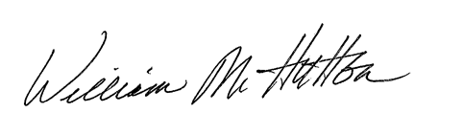

William M. Hutton
Executive Director

