06 May 2022

Honorable Members of the Higher Education Conference Committee
Chair Bernardy; Representatives Christensen; Klevorn; Keeler; O'Neill
Chair Tomassoni; Senators Rarick; Jasinski; Housley; Clausen

Re: BAM Written Testimony; HF3872

On behalf of the Builders Association of Minnesota (BAM), I would like to thank you for the opportunity to share written testimony. Our membership of nearly 1600 residential builders, remodelers, subcontractors, and industry partners are joined together through eleven local associations across Minnesota, and we are proud to be the statewide voice of the Minnesota Home Building Industry.

BAM is grateful to its members who have worked tirelessly and safely through the pandemic to provide housing opportunities to Minnesotans. We thank you for your public service, and the work you do to move Minnesota forward. Following are issues we’d like to highlight for your consideration:

BAM Strongly Supports:

▪️Senate language that adds “construction” to eligible fields of study for Workforce Development Scholarships (Art 2, Sec 9; UE1). Construction careers are often overlooked or under-valued in Higher Education, and we applaud the Senate for acknowledging their importance. Residential construction careers are challenging and rewarding, and our members are concerned about present and future workforce needs. We appreciate legislative efforts like these that highlight and grow opportunities for students to choose construction careers.

▪️Senate language that establishes the Skills Path Program. Providing secondary students with a clear pathway from high school to careers in skilled work and trades is critical to our members, and to meaningfully address ongoing workforce shortages.

BAM respectfully requests that these provisions be included in your conference committee report. We are happy to answer any questions you may have.

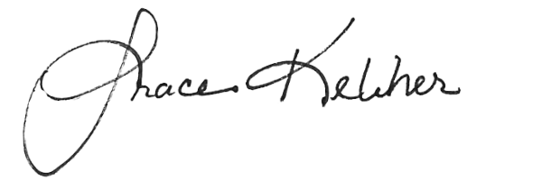
Sincerely,

Grace Keliher, Executive Vice President
Builders Association of Minnesota
161 St. Anthony Avenue, Suite 817 Saint Paul, MN 55103
grace@bamn.org / 612-501-3071

cc: Sean Herring, House Committee Administrator (Sean.Herring@house.mn)
Tom Brennan, Senate Committee Administrator (Tom.Brennan@senate.mn)

