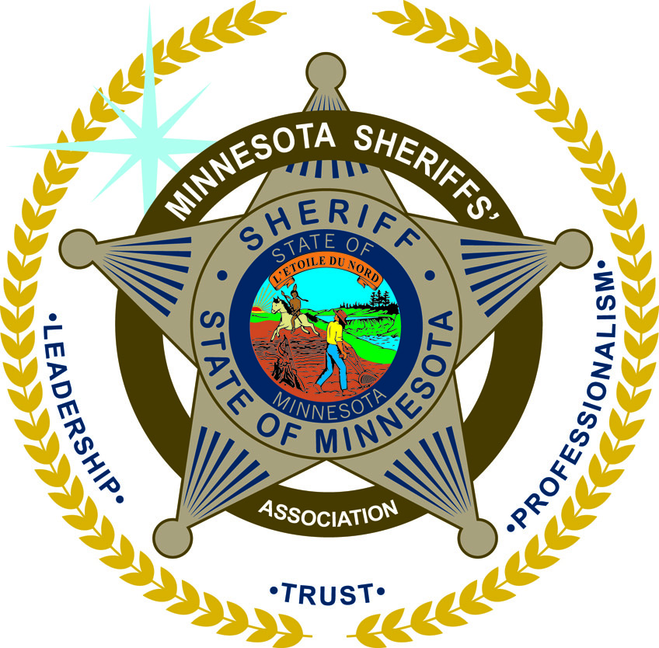
MINNESOTA SHERIFFS’ ASSOCIATION
___________________________________________________________________________________________________________________________________________

100 Empire Drive, Suite 222, St. Paul, MN 55103
Phone: 651.451.7216 Fax: 651.451.8087
Email: info@mnsheriffs.org

February 18, 2019

Representative Christensen and Members of the Minnesota House of Representatives,
The Minnesota Sheriffs’ Association supports HF 1149 providing conservation officers of the Minnesota Department of Natural Resources the authority to enforce all traffic laws of the State of Minnesota. This includes the ability to enforce DWI laws. Members of the DNR are well-trained licensed peace officers with the authority to enforce laws throughout the State of Minnesota. Granting DNR Conservation Officers the authority to enforce DWI laws will support all law enforcement in their goal to protect the safety of all Minnesotans.
The Sheriffs of Minnesota work closing with members of the DNR every day and are confident that they have the proper training to help keep the citizens of Minnesota safe.
Sincerely,
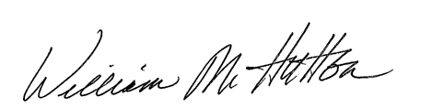
William M. Hutton
Executive Director

