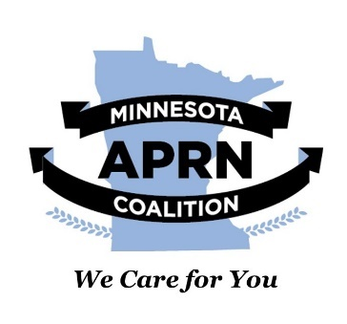

March 7, 2022

Representative Kristin Bahner

535 State Office Building

St. Paul, MN 55155

Dear Representative Bahner:

The Minnesota Advanced Practice Registered Nurses (APRN) Coalition endorses **HF 3989: Physician Assistants added to statutes.**  We also wish to thank you for the amendment adding APRN language to replace the more role-limited Certified Nurse Practitioner (CNP) term.

Like APRNs, Physician Assistants are vital in the provision of quality health care to Minnesotans. Updating outdated Minnesota statutes to reflect current practice is essential to ensure Minnesotans continue to receive the care they need without unnecessary barriers or interruptions.

We appreciate your leadership in this effort Representative Bahner. We are available for any questions or concerns you, Committee Members, or other Minnesota Representatives may have.

Sincerely,



Brian K Goodroad, DNP, APRN, CNP, FAANP

President

Minnesota APRN Coalition

Email: [admin@mnaprnc.org](mailto:admin@mnaprnc.org)

Cell: (651) 263-0783

Cc: