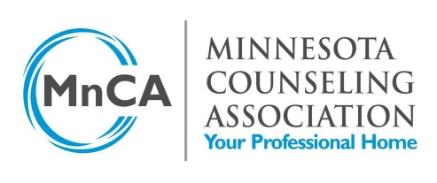

May 2022

Dear House and Senate Conferees:

The Minnesota Counseling Association (MnCA) urges you to support the Counseling Compact contained within SF4410. We are currently amid a mental health crisis across the country and Minnesota adopting the Counseling Compact would significantly create greater access for those seeking and others providing mental health care. Adoption of the Counseling Compact in Minnesota would especially help individuals living in rural areas, veterans, snowbirds, business travelers, and college students, ensuring vitally important continuity of care.

The Counseling Compact allows Licensed Professional Clinical Counselors (LPCC) privilege to practice across state lines in states that have ratified the compact. The Counseling Compact is currently law in 11 states and pending in 11 others. The Counseling Compact is budget neutral and the legislation has bipartisan support in the Senate and the House. The Board of Behavioral Health and Therapy is also in support of the Counseling Compact. In addition to the benefits listed above, the Counseling Compact would also:

- Enhance mobility for counselors who meet uniform licensure requirements.
- Increase access to care for clients, ensuring continuity of care when clients or counselors relocate or travel to other states.
- Allow military personnel and spouses to maintain their certifications when relocating with greater ease.
- Preserve and strengthen the current system of state licensure.

We urge you to support and pass the Counseling Compact in the State of Minnesota. Please feel free to reach out to us with any questions.

Regards,

Gillian Koch, M.Ed., LPCC
President
Minnesota Counseling Association
Presidentmnca@gmail.com

Tom Hegblom, Ph.D., LPC, LADC
Legislative Chair
Minnesota Counseling Association
legislativemnca@gmail.com

