Temporary Family Health Care Dwelling Bill

In our current housing infrastructure we have gaps that are causing both emotional and financial hardship for the aging and disabled. For example: if mom’s house isn’t accessible and she falls and breaks her hip, she likely would head to an institution to receive post acute care and recovery services. Unfortunately the local TCU has a waitlist, so mom either risks her health by returning to her unsafe home or she leaves her city, her community, and her family to find an open bed in another institution.

This story is all too common for many Minnesotans. The hardships incurred in these experiences effect entire families and their communities. This bill gives people options to look after their loved ones in a financially responsible and patient-centered way. The decisions made during that time will improve the lives of these families far into the future and will be another example of Minnesota setting the benchmark for healthcare delivery options.

Key Points:
- Budget Neutral, eventual cost savings for state could be immense.
  - Low to middle socioeconomically rated households can afford this service
  - Average Temp. Family Health Care Dwelling rental is $1250/month.
  - Can be an affordable option to those not able to/willing to utilize Medicaid EW, CADI, etc.
- DHS backed – recipient of a Live Well at Home grant that was recently extended into 2017.
- North Carolina, Virginia, and New York all have already passed a less stringent version of this bill.
  - Those bills had annual permits with uncapped annual renewals. This bill only permits a home for 6 months with a 1-time extension option if necessary (move-out date must be attached at that time).
- This will give cities a tool to classify, regulate, enforce, and maintain their city populations.

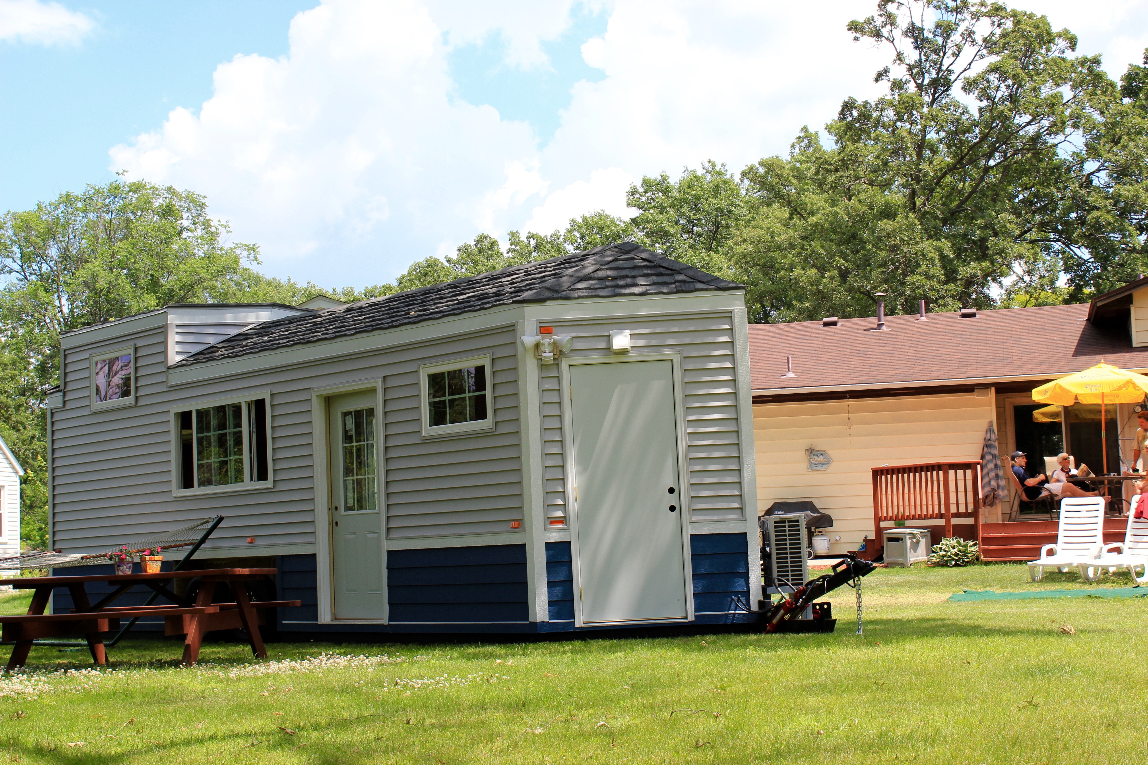

info@nextdoorhousing.com -more information at nextdoorhousing.com

