Vietnam Veterans of America
VVA’s goals are to promote and support the full range of issues important to Vietnam veterans, to create a new identity for this generation of veterans, and to change public perception of Vietnam veterans. VVA strives to achieve the following:
•Aggressively advocate on issues important to veterans
•Seek full access to quality health care for veterans
•Identify the full range of disabling injuries and illnesses incurred during military service
•Hold government agencies accountable for following laws mandating veterans health care
•Create a positive public perception of Vietnam veterans
•Seek the fullest possible accounting of America’s POWs and MIAs
•Support the next generation of America’s war veterans
•Serve our communities

Founding Principles

“Never again will one generation of veterans abandon another.”
VVA knows what returning veterans face. We have been through it before and we know that, despite all the rhetoric, returning veterans will face major problems. VVA will be here for as long as it takes to make sure that those who serve our country receive the care and respect they have earned.

The VVA Flag

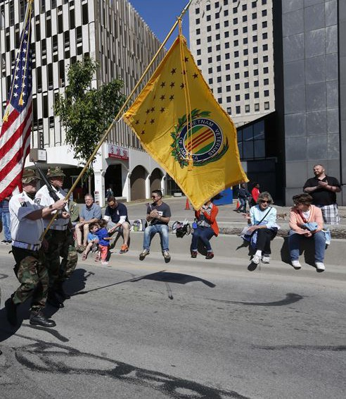
The VVA flag is an elegant presentation of American veterans’ service in the Vietnam War. VVA flags are proudly displayed at all Vietnam Veterans of America meetings and functions and in Veterans Affairs Committee chambers of both the U.S. Senate and the U.S. House of Representatives.
- The background color is golden yellow, the primary color of the flag of the Republic of Vietnam and the ribbon of the Vietnam Service Medal.
- In the “hoist” of the flag, the seventeen brown stars, arranged in three vertical rows, represent the seventeen official campaigns of the Vietnam War.
- The insignia of VVA, including the identification inscription Vietnam Veterans of America is centered between the campaign stars and the “fly” of the flag. The VVA insignia incorporates the design of the flag of the Republic of Vietnam and the ribbon of the Vietnam Service Medal, which was awarded to all men and women who served in Southeast Asia and the contiguous waters or air space there-over from March 15, 1962, through January 28, 1973.
- Surrounding the insignia, in natural colors, is a wreath containing a laurel branch and a sheaf of rice stalks. The two are tied together at the base with a strand of black barbed wire. The rice represents Southeast Asia, and the laurel signifies honor to all who served there. The black barbed wire serves as a reminder of the POWs and MIAs who are still unaccounted for.

